Chapter 2. Physical basis of dielectric polarization
The electrical polarization is most important property of dielectrics. In active dielectrics polarization is induced not only the externally applied electric field, but it can be spontaneous due to intracrystalline electrical moment. In the non centre symmetric dielectrics polarization can be induced by the mechanical action. In this chapter the only polarization induced by the external electrical field is discussed.
Electrical charges in the dielectric structure are bound very tightly, therefore, the concentration of free charge carriers, causing an electrical conductivity in dielectrics, is usually very small. In this connection, in further consideration of the dielectric polarization it is assumed for simplicity the complete lack of electrical conductivity: σ = 0.
2.1. Macroscopic consideration of the polarization

Electrically induced polarization is originated under the influence of an external electrical field: electrically charged particles, that make up the dielectric, displace from their equilibrium position, resulting in the induced electrical moment: M = 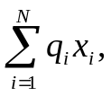 where N is the number of charged particles in the dielectric; q_{i} is electrical charge of the i-th particle; x_{i} is displacement of this charge from its equilibrium position under the influence of an electrical field. The unit of measurement of the electrical moment is a "Coulomb per meter" [M] = C/m.

Electrical field, induction and polarization. The bulk density of the electrical moment is called polarization: P = M/V, where V is volume of the polarized dielectric. Unit of measure for polarization is [P] = C/m², which corresponds to another definition of P as the surface density of the bound charge on the electrodes of polarized dielectric capacitor, Fig. 2.1, a.
Polarization quantifies the magnitude of the electrical moment in the dielectric and depends on the value of the electrical field, as well as on the structural characteristics (chemical composition) of the dielectric. Obviously, the higher the electric field strength the larger is the polarization. Unit of the electrical field intensity is [E] = V/m.
In general, the P(E) dependence may be rather complicated, Fig. 2.1, b, but for the majority of dielectrics, if the electrical field is not very large, the relationship between P and E can be regarded as a linear:
P = ε₀χE, (2.1)

where χ is dielectric susceptibility (dimensionless parameter). In the vacuum the susceptibility is absent (χ = 0) while in most of dielectrics it is found as χ = 0.5…10. However, in some crystals (which, however, are of the largest interest of this survey) the χ = 10…1000 and even more. Parameter ε₀ = 8.854⋅10^{–12} F/m is called the electrical constant, which in SI agrees the dimensions of P and E (F is the farad, unit of the capacitance, [F] = C/V).

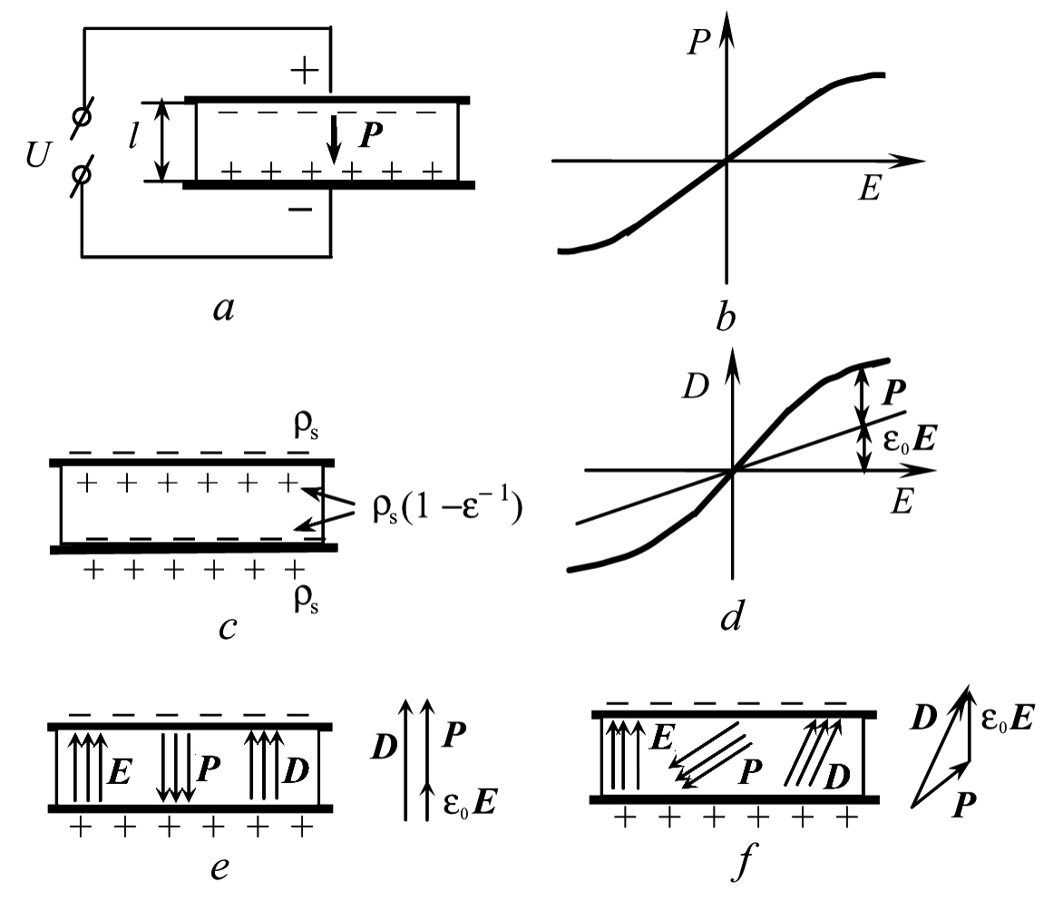
Fig. 2.1. Macroscopic description of electrical polarization

Except of the polarization, there is another important parameter to describe electrically induced polarized state in dielectric, namely, the electrical induction:
D = ε₀E + P. (2.2)
Induction is defined in the same units as the polarization: [D] = C/m², and it is also characterized by a surface density of the electrical charge on the metallic electrode, Fig. 2.1, e. If the dielectric with metallic electrodes is represented as an electrical capacitor (Fig. 2.1, a), the electrical induction characterizes the total charge on the plates of the capacitor: D = ρ_{s}, while the polarization P characterizes only the portion of total charge, which is related to the charges of opposite sign adjacent to the surface of the polarized dielectric. Parameter ε is introduced as proportionality factor between the induction and electrical field:
D = εε₀E. (2.3)
Dimensionless parameter ε is the relative permittivity (dielectric constant), which is related to the dielectric susceptibility χ with simple equation ε = 1 + χ.
The dielectric constant is usually determined by the electrical capacitance of the capacitor. In the case of a planar capacitor C with surface area S and thickness h, the permittivity is 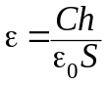. Such capacitors are most often used in the industry and for dielectrics investigation.
For a cylindrical capacitor C having outer and inner diameters D and d respectively, and the axial length l, the permittivity can be computed as 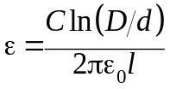. Dielectric components of such form are, for example, coaxial cables, cylindrical piezoelectric elements, etc.
If the studied capacitor C has a spherical form (such as piezoelectric elements for sonar, or spherical pyroelectric element), it is characterized by the values of outer and inner radiuses of spheres as r₁ and r₂; the permittivity can be calculated as 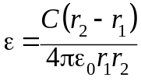.

Dielectric nonlinearity. One type of possible nonlinear dependences of the polarization on field, P(E), is shown in Fig. 2.1, b and it is associated with dielectric constant dependence on electric field, because ε = 1 + P/ε₀E. In principle, the ε(E) changing should be observed in all dielectrics. However, in most of them, the nonlinearity can be considered only when dielectric is subjected to extremely large dielectric electric field: 10⁸...10¹⁰ V/m, while the dielectric strength of even solid dielectrics is usually less: E_{br} = 10⁷...10⁹ V/m.
Thus, in the majority of dielectrics the electrical breakdown occurs earlier than they might show noticeable nonlinearity. However, in some materials – ferroelectrics and paraelectrics – the nonlinearity can be essential as early as in the electrical field of 10⁶ V/m, that is much smaller than the electrical breakdown field E_{br}. It is necessary to notice also, that the optical nonlinearity may be seen in any dielectric when expose to powerful laser beam as a light might be self-focusing.
However, nowadays, with the advent of technologies, it is possible to obtain high-quality in thin (nanoscale) dielectric layers, in which the dielectric strength is higher by two to three orders of magnitude, so the voltage of electrical breakdown greatly increases, and the non-linearity of even conventional dielectrics acquires significance.
Nonlinearity is determined not only by the chemical composition but also by structural features of solid dielectrics, and, particularly, the nonlinearity is noticeable in the vicinity of phase transitions. Because of huge variety of dielectric structures and their polarization mechanisms, there is no simple way to estimate nonlinearity in all of them, so specific method should be applied to calculate nonlinearity of the particular type of the dielectric. Therefore, here the nonlinearity is estimated only in general.
To describe the functional dependence of the dielectric nonlinearity ε(E), the permittivity should be presented in the form of a rapidly convergent series:

ε(E) = ε + ε₁E + ε₂E² + ε₃E³ + ε₄E⁴ + .... (2.4)

In the dielectrics with a centre-symmetrical structure, the coefficients of odd powers E vanish, so that the dependence ε(E) is even. Taking into account the rapid convergence of the series (2.4), the parameter ε₂ can be linked with differential nonlinearity parameter N_{ε}:
ε(E) = ε + ε₂E²; 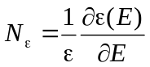; 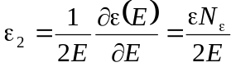. (2.5)

In the case of non centre-symmetrical dielectrics, both even and odd degrees in the equation (2.4) should be considered. However, in view of the rapid convergence of the series (2.4), it is enough to consider only the coefficient ε₁ with which it is possible to express the nonlinearity parameter:

ε(E) = ε + ε₁E; ε₁ = ∂ε(Е)/∂Е = εN_{ε}. (2.6)

The dependence of the dielectric constant on electrical field reflects the microscopic processes of polarization, when dielectric polarizability depends on the inter-crystalline field F (associated with the field E). The discussions of microscopic models of dielectric nonlinearity will be conducted later in the Sections 2.3…2.7.
Therefore, the nonlinearity of the electrical induction dependence on the electrical field is always takes place, in the very strong electrical field even the vacuum is nonlinear. However, in the vast majority of dielectrics, the nonlinearity can be observed only in the electric fields comparable (or greater) than the field of the electrical breakdown. The reason for this is that the internal energy of the electromagnetic interactions in atoms, molecules and crystals is much higher than the energy of the possible non-destructive impact on the dielectric. However, there are exceptions:
1. Because of the inertia of the electrons, the breakdown at optical frequencies does not happen because there is no enough time to grow electronic avalanches. Therefore, in the strong electrical field of giant laser pulse (when the intensity of this field is close to the internal fields of atoms), the nonlinearity of optical polarization becomes sufficient for applications, that is the physical basis of the nonlinear optics.
2. Near the phase transitions (for example, ferroelectric transition) the forces of the interaction of nearby atoms are almost compensated, therefore, the external influences, including the electric field, results in a significant response: permittivity is large (ε ~ 10⁴), while the non-linearity N_{ε} is proportional to ε³.
3. In connection with the achievements of nanotechnology, it is possible to obtain high-quality thin layers of dielectrics in which the electrical breakdown field increases in thousands times. This implies the possibility of obtaining (and to use) a significant dielectric nonlinearity in the case of usual mechanisms of polarization.

Dielectric anisotropy. Unlike most of dielectrics (mostly insulating materials), which are isotropic, that is identical in all directions, the electrical properties of active dielectrics are usually characterized by the anisotropy of the electrical, thermal and mechanical characteristics. In active dielectrics, the electrical and electromechanical parameters are different in various directions in the crystal or texture.
In this context, is important to note that the electrical field E, polarization P and electrical induction D are vectorial quantities. In the conventional isotropic dielectrics the vectors D, E and P are collinear. Figure 2.1, e shows these vectors in an electrical capacitor containing isotropic dielectric.
However, in an anisotropic dielectric the vectors D, E and P differ in their orientation. At that, the vectorial relation D = ε₀Е + Р remains correct.
If the dielectric is isotropic, the vector sum corresponds to the sum of the modules of the vectors, since the direction of all three vectors coincides. In such isotropic dielectric the electrical field is generated by the charges on the capacitor plates, and therefore, it is directed perpendicularly to the electrodes. In anisotropic dielectric, the induced polarization is directed in accordance with the elastic bonds of the constrained electrical charges, so that the vector P is not parallel to the vector E. And what is more, it is considered to accept that P is directed from the negative charge to positive, Fig. 2.1, f. As a result, the direction of total electrical induction vector D is also different from the direction of the vector E, so that the permittivity, which characterizes the relation between D and E (D = εε₀Е) is a peculiar parameters that are various in the different directions.

Tensor of permittivity. In contrast to the scalar parameters (such as material density, temperature or specific heat), the vectors are defined by three parameters – their projections on the coordinate axes. Accordingly, the polar vectors D, E and P can be represented without a vector notation, but with a subscripts m, n = 1, 2, 3. Conversion from one vector to another is necessary to describe electrical polarization, for example

D_{m} = ε₀ε_{mn}Ε_{n}, P_{m} = ε₀χ_{mn}Ε_{n}. (2.7)
It is seen, that in the anisotropic media, the tensor components ε_{mn} and χ_{mn} with two indices are necessary. One of these comes from the "impact" vector (in this case it is E_{n}), while another vector is a "response" (e.g., P_{m}), the direction of which may not correspond to the direction of the impact.
Thus, for the analysis of electrical, mechanical and electromechanical properties of the crystals, the tensors should be used which are physical or mathematical quantities that are transformed by the different laws comparing to scalar quantities.
As it is well known, the vectorial algebra differs from ordinary algebra by introducing the concepts of the gradient (for example, Е = gradϕ, where ϕ is electrical potential), the divergence (one of Maxwell's equations is divЕ = ρ) and the rotor (respectively, other Maxwell equation is rot Е = − ∂B/∂t). In this case, the vectors are the first rank tensors, and they are recorded with a single subscript: Ε_{n}, D_{m}, etc.
Scalar values, according to this classification, are zero rank tensors, which are written with no lower indices, and are converted by ordinary laws of algebra, for example, ΔQ = C_{V}ΔT, that is a change in the quantity of heat which is equal to the product of the heat capacity on the temperature change.
The permittivity ε_{mn} and susceptibility χ_{mn}, as well as the conductivity σ_{mn}, the magnetic permeability μ_{mn} and a number of other parameters of anisotropic crystals and textures are the second rank tensors. Double letters in the indices denote the summation: for example, D_{m} = ε₀ε_{mn}Ε_{n} means m, n = 1…3. Each of the equations (2.7) is shorthand for the three equations. In this case:
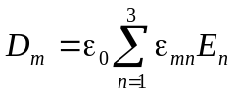,
or in more detail:
D₁ = ε₀ (ε₁₁Ε₁ + ε₁₂Ε₂ + ε₁₃Ε₃);
D₂ = ε₀ (ε₂₁Ε₁ + ε₂₂Ε₂ + ε₂₃Ε₃);
D₃ = ε₀ (ε₃₁Ε₁ + ε₃₂Ε₂ + ε₃₃Ε₃).
Parameters ε_{mn} are associated with various components of the vectors D_{m} and E_{n}: for example, ε₁₃ is a material constant, which connects the electrical displacement component D₁, induced in an anisotropic crystal by the component E₃ of an externally applied electrical field. In an isotropic dielectric, obviously, ε₁₃ = 0 and ε₁₂ = 0, while ε₁₁, ε₂₂ and ε₃₃ are the only nonzero values, all of which are identical, and, therefore, can be written as a scalar quantity: ε_{mn} = ε.
The components of permittivity tensor ε_{mn} might be presented in the form of a matrix
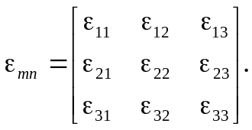 (2.8)
In the case of an isotropic dielectric (glass, amber, plastic, non-polarized ceramics, etc.), this matrix contains only the main diagonal component ε_{mn} = ε. However, after prolonged application of a strong electric field to the ferroelectric ceramics, it becomes polarized: domains are oriented in the field, so that there is a preferred direction – the polar axis. For such case of polarized ferroelectric which turns into a texture, where the highlighting axis is z (in the direction of z = 3). The limiting properties are observed along this axis (ε₃₃) and perpendicular to it (ε₁₁ = ε₂₂). Corresponding matrices have the form:
ε_{mn isotropic diel.} = 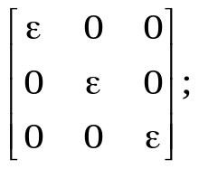 ε_{mn polarized ceramics} 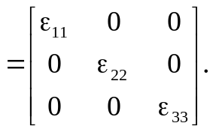
For the low-symmetry crystals (with a small number of symmetry elements), and in the case of arbitrary orientation of the electrical influence vector (not along the principal axes of the crystal), the permittivity tensor can have all 6 (the maximum) of the various components.
From the matrix (2.8) it is formally follows that such components must be 9, but ε_{mn} tensor is a symmetric tensor (as well as the conductivity tensor σ_{mn}), this means ε_{mn} = ε_{nm} (as well as σ_{mn} = σ_{nm}). The matrix (2.8), respectively, is a symmetric as to the main diagonal. Such matrices can always be transformed to the diagonal form, when all components of the tensor ε_{mn}, except for the diagonal components, vanish.
From analytical geometry, it is known that the main (diagonal) components of matrix can be represented by the axes of the ellipsoid. In this case, it is the permittivity ellipsoid:
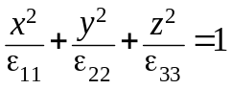.
In the isotropic dielectric ε₁₁ = ε₂₂ = ε₃₃, and dielectric ellipsoid becomes a sphere. In the tetragonal, hexagonal and trigonal crystals, as well as for the polarized ferroelectric (texture), the components ε₁₁ = ε₂₂, but they differ from the ε₃₃, so that the dielectric ellipsoid becomes an ellipsoid of rotation. For this type of the active dielectrics, there are two main values of the permittivity: ε₃₃ и ε₁₁ that are experimentally determined as the permittivity along the crystal main axis and perpendicular to it. Figure 2.2 gives a geometric representation of the different material tensors; dielectric ellipsoid is shown in Fig. 2.2, c.

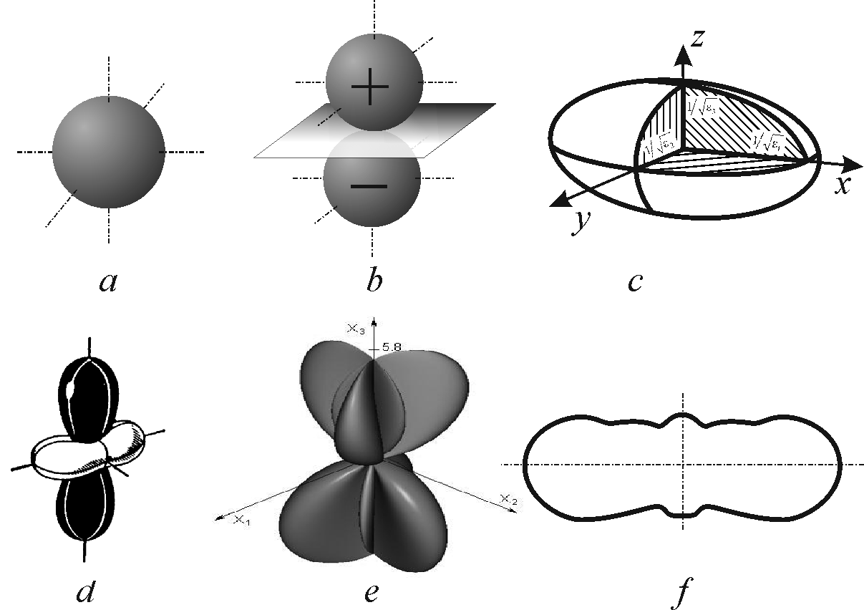
Fig. 2.2. Images of material tensors of various ranks: a – zero rank (scalar); b – first rank tensor (pyroelectric coefficient); c – second rank tensor (dielectric constant); d – second rank tensor (coefficient of thermal expansion), e – third rank tensor (piezoelectric modulus);
f – projection of fourth-rank tensor (elastic compliance)

As an example, hexagonal crystalline piezoelectric crystal quartz has ε₁₁ = 4.5 and ε₃₃ = 4.7, tetragonal ferroelectric barium titanate crystal shows permittivity ε₁₁ = 4000 and ε₃₃ = 200 (at 300 K), while potassium dihydrogen phosphate (KDP) at 300 K has ε₁₁ = 42 и ε₃₃ = 22.
Crystals of low symmetry (triclinic, monoclinic and rhombic) are characterized by dielectric ellipsoid of general form, and have three main values of ε_{mn}. For example, ferroelectric Rochelle salt is characterized by ε₁₁ = 2000, ε₂₂ = 8.5 and ε₃₃ = 7.5. The permittivity of cubic crystals (highest symmetry) looks like scalar, such is NaCl with ε = 5.6.

In the description of the induced polarization (arising in dielectrics in an external electric field), tensor ε_{mn} is used in cases where the exposure (intensity) parameter is the electric field E_{n}, and the induction D_{m} is a response (extensive parameter). In the opposite case, the tensor of inverse permittivity ca be introduced: β_{mn} =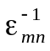. The dimensionless physical quantity β_{mn} is called the dielectric impermittivity. This parameter is used, for instance, in the equations of the piezoelectric effect, which will be discussed in Chapter 7, because in some cases it is not enough to consider only the tensor ε_{mn}.
The magnitude of the permittivity of piezoelectric is strongly dependent on the mechanical conditions in which the crystal or texture is studied or used. When an electric field can freely deform the piezoelectric, its seeming dielectric constant will be higher than in the case where the mechanical strain is restricted. This interesting and important effect is due to the fact that a piezoelectric is an electromechanical transducer, so the electrical energy that supplied to piezoelectric is responsible not only for the electric displacement of electrons, ions or dipoles, but also for macroscopic elastic deformation of the piezoelectric as a whole.
In this connection it is it is necessary to distinguish the ε^{X} (permittivity of a free crystal, in which there are no mechanical stresses X = 0) and, along with other mechanisms of polarizations, the piezoelectric polarization is present, and the ε^{x} (permittivity of a clamped crystal, in which the piezoelectric strain is absent, x = 0), so there are only microscopic mechanisms of polarization. For the piezoelectric the inequality ε^{X} > ε^{x} is always true, because the ε^{X} contains the additional mechanism of reversible energy storage – the elastic displacement of the crystal.
The piezoelectric contribution to the dielectric constant may be quite different. For example, the accurate measurements of quartz show 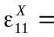 4.52 and 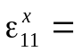 4.43, 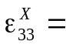 4.70 and 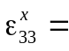 4.64; so that in this crystal the piezoelectric contribution is small: 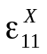− 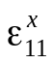 = 0.09 и 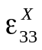−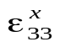 = 0.06. However, in the crystal of barium titanate at 300 K the components of permittivity are: 4000 and 2000, = 200 и = 90, so the piezoelectric contribution to the dielectric constant in this crystal is essential: − = 2000 while − = 110. Therefore, in barium titanate electromechanical contribution to permittivity shows large anisotropy, and it is approximately half of the total value of the dielectric constant.

2.2. Electrical polarization mechanisms classification

Microscopic conception of the polarization mechanisms can be reduced to a few relatively simple models of the electrical moment appearance and changes in the electrical field. Since the quantum-mechanical calculations of the atomic electronic shells interaction with the nuclei are difficult even for some simple molecules, then to describe the polarization in the bodies consisting of a set of atoms, ions and molecules it is useful to consider the simple models of the polarization on the basis of classical concepts.
Under electrical field applied to dielectric, the electrically connected charges are displaced relatively to each other, whereby the dielectric becomes polarized. As already mentioned, the external electric field induces in a dielectric the elementary electrical moments p = qx, where q is the shifting electrical charges and x is their mutual displacement.

Field-induced electric moment may get contribution from:
• electrons, displacing from their equilibrium positions in atoms;
• ions, deviating from the equilibrium state in the crystal lattice;
• dipoles (polar molecules), changing their orientation in the electrical field;
• macro-dipoles (electrically charged particles or complexes in an
inhomogeneous structures (ferroelectrics, piezoceramics).

Electrons, ions and dipoles (including macro-dipoles) can form an electrical moment (i.e., the polarized state) through various mechanisms. If these particles are bound to the structure elastically and relatively rigid, the external electrical field or other exposure (in piezoelectric – mechanical) can lead only to a very small (even compared with atomic dimensions) deviations from the unpolarized equilibrium state. However, since in the process of polarization involves all particles of the dielectric, even these small relative displacements of charges cause significant integral effect – the polarization. Such a mechanism is called the elastic polarization.

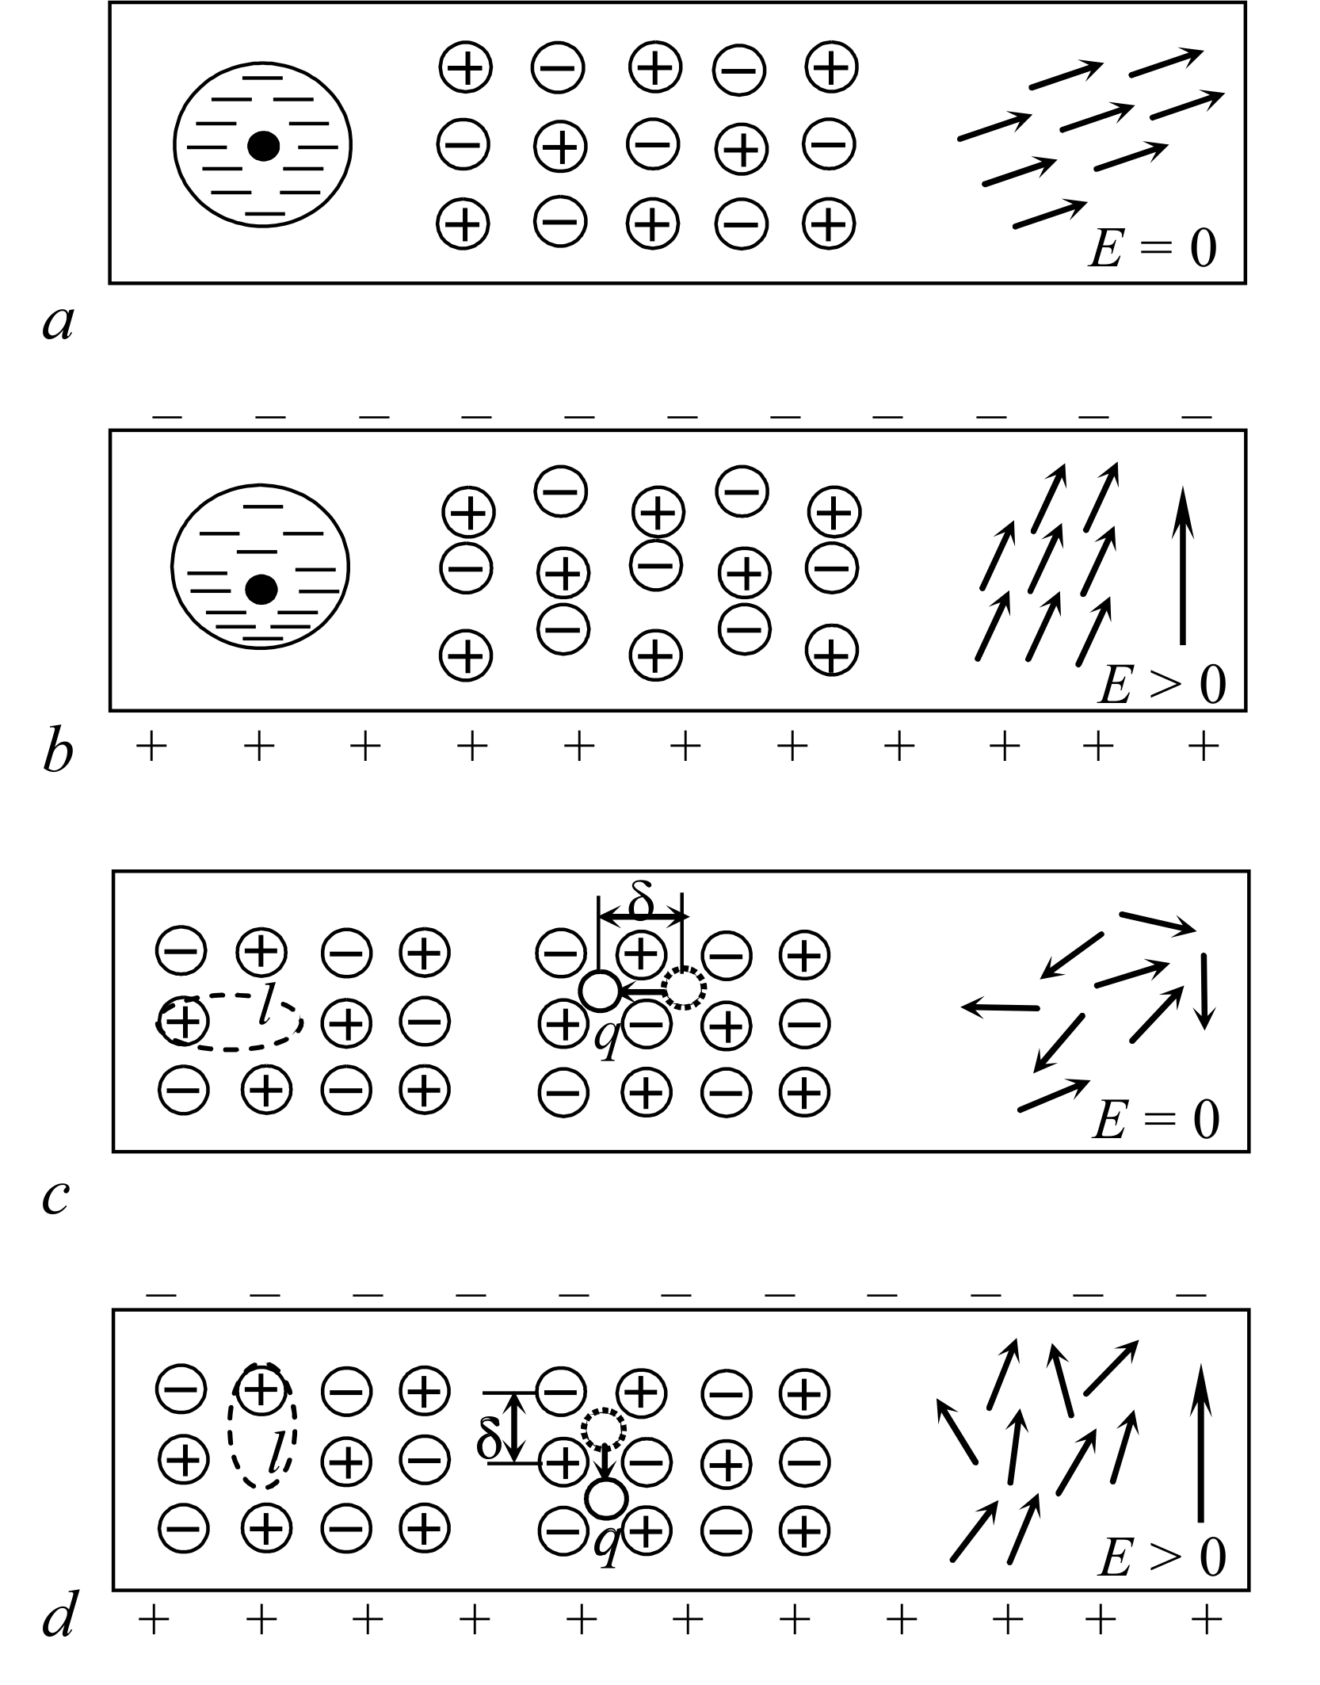
Fig. 2.3. Microscopic mechanisms of polarization: a, b – three mechanisms of elastic polarization: fragments of dielectric in absence of electric field E and when it is applied;
c, d – three mechanisms of thermal polarization: fragments of dielectric in electric field E absence, and when it is applied

The basic physical mechanisms of elastic polarization are shown schematically in Fig. 2.3, a and b. In an unpolarized state (E = 0), the electronic shells of atoms are symmetrical with respect to the nuclei (Fig. 2.3, a, the left-hand fragment), so that the effective centre of the negative charge coincides with the positively charged nucleus. Accordingly, the elemental dipole moment is zero (p = 0), since it is determined by the product of qx = р, and the relative displacement of the charges q⁺ и q⁻ is absent, i.e., x = 0.
If the electric field is applied (Fig. 2.3, b) in the each atom, molecule or ion, their electronic shells become distorted and displaced with the respect to the nuclei, whereby the centre of negative charge shifts relatively to the positively charged nucleus, so that a elementary polar moment appears as p = qx > 0. This is the mechanism of the electronic elastic polarization.
In an ionic crystal, in the absence of an externally applied electric field (see Fig. 2.3, a, the central fragment), there are cations and anions in the crystal lattice sites. The system of charges is electrically neutral, and it does not form any electrical moments (polarization). But in an external electric field (Fig. 2.3, b), the cations and anions are displaced under the influence of Coulomb forces, forming the polar lattice of q⁺⎯q⁻ with the elementary electric moments p = qx > 0. By these way in the ionic elastic polarization arises that for ionic dielectrics is of great importance.
The energy characteristics of the elastic polarization process are shown in Fig. 2.4, a. The elastic energy of bound particles (ions in crystal, electrons in atom, dipole in lattice) is given by the equation U = ½ cx², where c is the elastic coupling coefficient and x is elastic displacement from the equilibrium position.
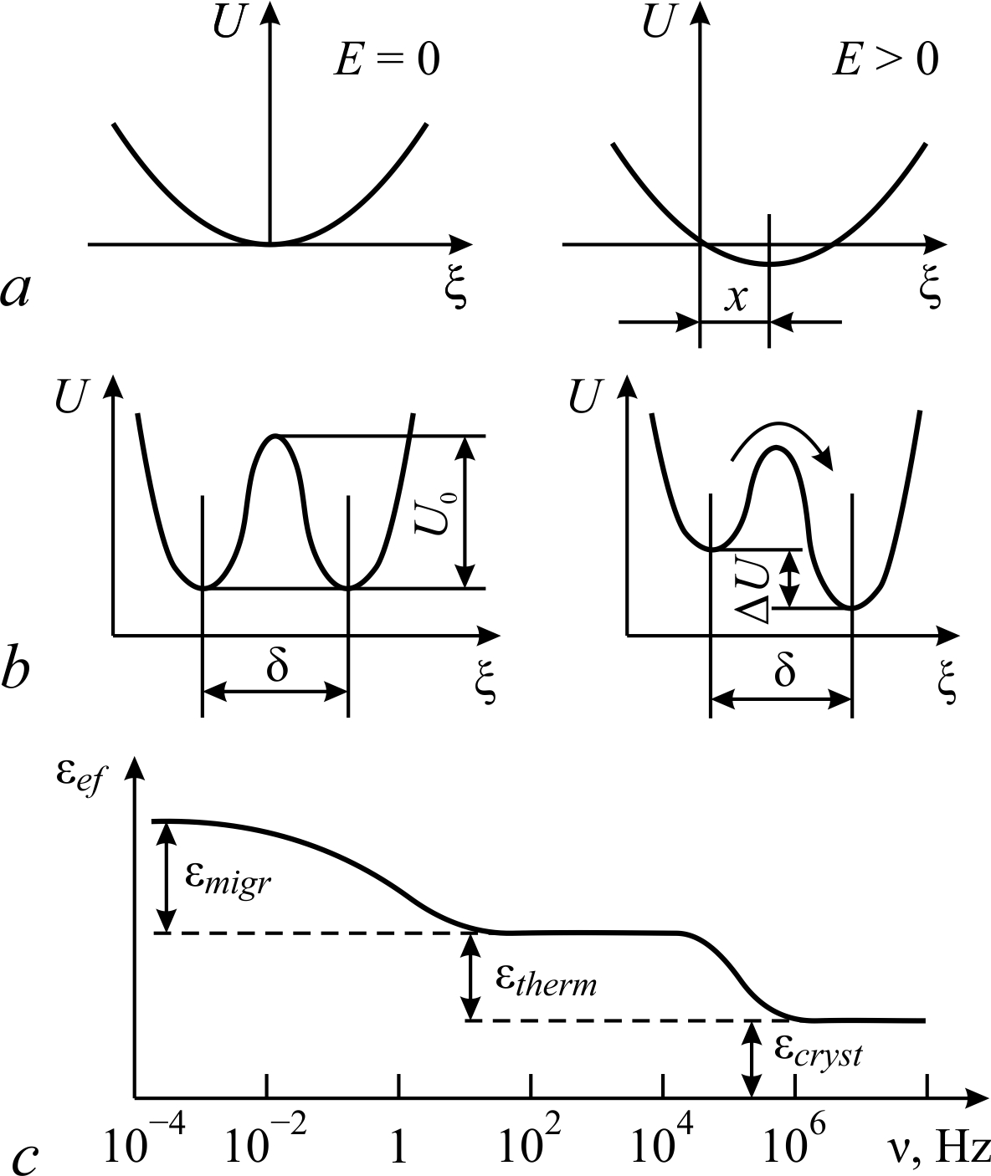

Fig. 2.4. To different polarization mechanisms explanation of: a – elastic energy change at deformation mechanism; b – change in thermal energy (relaxation mechanism); c – frequency dependences of the dielectric contributions from migratory, thermal and fundamental (lattice) polarization
In the absence of external influences x = 0, and the particle is localized in the bottom of the parabolic potential well. Under applied electric field the particle acquires extra energy U = ½ cx² – qхE. That energy gain is added to elastic energy, so the minimum of energy shifts to the position of x > 0 (Fig. 2.4, a) in which the particles already have elementary electrical momentum p = qx and contribute to the polarization. Shutting the field leads to a rapid establishment of former equilibrium position when x = 0, and the elastic polarization disappears.
On the right-hand fragments of Fig. 2.3, a and b, the third elastic mechanism of polarization is shown, namely, the elastic rotation of the dipoles. It is possible only in the case of own polarity of dielectric (existing in the absence of an external field) that is observed in many active dielectrics. The dipoles ordering in such a polar lattice is conditioned by the internal interaction (usually, by the mixed ionic-covalent bonding) and spontaneously oriented by the intracrystalline field, which they themselves created. The external electric field alters the orientation of all dipoles of entire structure, thereby electrical field changes the electrical dipole moment, i.e., its new orientation induced the polarization (Fig. 2.3, b, right-hand fragments). This is the mechanism of the dipole elastic polarization.
By switching off externally applied field, all the above said mechanisms of polarization disappear very rapidly: dielectric returns to its equilibrium (unpolarized) state. Electrons occupy electrically symmetrical position relatively to the nuclei due to Coulomb forces of attraction, cations and anions will return to their stable (equilibrium) position in the crystal lattice sites by the forces of repulsion of the electron shells of the ions. The area of coordinated dipole polarization returns to its original position (in which energy of oriented dipoles system is minimal). But sometimes – in the ferroelectrics – there are the areas called the domains that can remain in the rotated state.

Besides the elastic (deformation) polarization, the electrons, ions and dipoles (macro-dipoles) may also participate in the mechanisms of both thermal and migratory polarization.
In the case of weak bonding in the structure, some electrons, ions and dipoles are significantly affected by the thermal (chaotic) motion of particles in a dielectric structure, and this may have an influence on the polarization, Fig. 2.3, c and d. These pictures show that such particles (usually impurities) are isolated in the local (nano-scale) areas, so they are not the main structural elements of the dielectric. Electrically charged impurities relatively loosely bound in the crystal lattice, but they are forced to be localized in the vicinity of the structural defects in the dielectric.
Remaining localized in the nano-volumes, these particles, under the influence of the thermal motion, perform the thermally activated jumps, moving over distances of atomic dimensions order. Therefore, their abrupt displacement in 10⁴...10⁶ times exceeds the value of small elastic displacements of the main structural units of the crystal (that produce elastic polarization). That is why these jumps can have a significant effect on the dielectric constant.

Electronic thermal polarization is due to the weakly bounded electrons, for example, the electrons, compensating the structural defects. These defects, for example, include the anion vacancies (lack of negative ions), as it is shown in Fig. 2.3, c, the left-hand fragment. Charge compensation occurs because the crystal lattice always should be electrically neutral: that is, the number of negative charges in it equals to the number of positive charges.
The electron, which charge compensates the charge of wanting anion, is localized near one of the surrounding position cations; at that, the orbital of this electron is strongly deformed: it is stretched out to an anion vacancy to compensate the absent charge, Fig. 2.3, c, left-hand. This leads to the spontaneous formation a local electrical moment р₀ = ql₀, where l₀ corresponds approximately to the lattice constant (~ 0.2 nm). The magnitude of this moment is not determined by the external electric field; while such "own" dipole moment р₀ thousands of times higher than possible electric moment induced by the external field elastic polarization (p = qx, where x is induced elastic displacement, has the order of 10^{–6} nm).
Weakly bonded electron (that is localized near the anion vacancy) even in the absence of an external field, from time to time, under the influence of thermal chaotic motion jumps from one of neighbouring cation to another, overcoming the energy barrier U₀ (Fig. 2.4, b). At that, the direction of inserted dipole moment p₀ should be changed. Despite the fact that the quantity of these defective places in the real dielectric is rather big (10²⁴...10²⁶ m^{–3}, as compared with concentration of basic structural units of the crystal ~10²⁸ m^{–3}), the macroscopic polarization in the crystal does not arise because all "own" dipoles are oriented randomly at any time.
Externally applied electric field reduces the potential barrier (Fig. 2.4, b) that lead to excessive orientation of "electron-cation" dipoles in accordance with the applied field (Fig. 2.3, d, left-hand fragment). Such is, in general terms, the mechanism of the electronic thermal polarization. This polarization is called as “thermal” because the electron jumps between cations due to the thermal energy of the crystal. The electric field, that has low impact energy ΔU < k_{B}T (Fig. 2.4, b), leads only to a certain redistribution of local electrical moments p₀ orientation.

Ionic thermal polarization mechanism (Fig. 2.3, c and d, the middle fragments) is largely similar to the thermal electronic mechanism. It is assumed that in the crystal lattice the impurity (embedded) ions are present that usually have small ionic radius (some of positive ions). This model is close to the ionic crystals doped with lithium ions or protons (one of experimental example). It is assumed that the impurity cations are located in the interstices of the structure, and their charge compensation is carried out due to the increased charge of one of the neighbouring anions. In the vicinity of such anion, the impurity ion makes thermally induced jumps.
These jumps are hampered by a potential barrier (Fig. 2.4, b), because for change in its localization the impurity ions need to overcome the repulsive forces of the electron shells of the neighbouring ions. Dipole moment p₀ is created between the jumping impurity ion and the fixed charge-compensating anion (that has larger radius).
When the impurity ion makes hopping in the vicinity of its localization, changing the direction, the electrical moment with the anion is formed. In the absence of an external field, the set of such polar defects are reoriented chaotically, that usually do not lead to an integral polar moment – polarization. (However, there are some uncommon examples when interaction between such polar defects leads to the spontaneous polarization – artificial ferroelectricity).
In the externally applied electrical field E (Fig. 2.4, d) along hopping direction the asymmetry appears, and thereby a macroscopic polarization arises (in this case – the thermal ionic polarization). After the switching off the electrical field, due to the disorienting effect of thermal chaotic motion, electrically induces thermal polarization gradually disappears.
The energy barrier U₀, which should be overcame by the impurity ion (Fig. 2.4, b), is much greater than the energy of thermal motion of the particles in a dielectric: U₀ >> k_{B}T. However, the probability of thermal hopping of electrons or ions (as well as the likelihood of thermal reorientation of dipoles) increases with increasing temperature.
These thermally activated jumps occur at a distance δ which is defined by the features of the crystal structure and defects, but does not depend on the external field E (as opposed to elastic polarization, when the polarization is determined by the size of displacement: x ~ E). In case of thermal polarization, the external electrical field only changes the probability of hopping over barrier particles. One of the potential wells, as compared to the other, becomes deeper on ΔU << U₀. This value depends on the applied field: ΔU = qδE, that is the contribution of the electrical energy at a distance of thermal hopping.

Dipole thermal polarization in crystals and textures can be approximately characterized by the model shown in the right-hand part of Fig. 2.3, c and d. In the absence of an external field, the "hard" dipoles already exist, but they are distributed randomly. Externally applied electrical field results in preferential orientation of the dipoles in the system, i.e., the bulk electrical moment appears. In reality, the possibility of thermal dipole polarization in the active dielectrics is limited to a certain number of stable dipole orientations (in accordance with the symmetry of crystal or texture). In the absence of an external field, the dipoles are oriented uniformly in all permitted directions; after electrical field is switching on the likelihood of dipole orientation in a favourable direction increases.

It is obvious, that thermal polarization mechanisms are much slower in comparison with the elastic polarization. In the case of elastic polarization, the polarized system of elastically bounded charges, after electric field removal, returns to its equilibrium (non-polarized) state in a very short time 10⁻¹²…10⁻¹⁶ s. On the contrary, in the case the thermally activated polarization, the thermo-electro-diffusion occurs for "semi-free" electrons or ions through the potential barriers. It is obvious that such a process is relatively slow: it needs time of about 10⁻²…10⁻⁹ s. At that, the time of thermal relaxation is strongly dependent on temperature, which characterizes the intensity of thermal motion.

Migratory polarization, which might be peculiar for certain active dielectrics (polarized textures) is the slowest mechanism, Fig. 2.4, c. When it happens, the related charges move at the highest (almost macroscopic) distance. In this case, the accumulation of electric charges takes place on the boundaries of the irregularities (between-crystallite layers, interstices, large defects) determines the space-charged polarization. This mechanism significantly increases the low frequency capacitance of electrical capacitor containing heterogeneous dielectrics. Migratory (space-charged) polarization can not be attributed to the microscopic mechanisms of polarization and, therefore, the dielectric constant calculated by the geometric dimensions and capacity of the capacitor, in the case of migratory polarization is called as "effective" ε_{ef}.
In the piezoelectric and pyroelectric textures (ceramics), the large dipole groups are involved to migratory polarization (by orientations of different sizes domains) that also should be described by the ε_{ef}.
In the frequency dependence of permittivity, the contributions of migratory polarization (ε_{ef} = ε_{migr}) and thermal (relaxation) polarization (ε = ε_{therm}) are shown in Fig. 2.4, c. In the case of a high concentration of the charged structural defects, these dielectric contributions may be much larger than the dielectric constant of pure (ideal) crystal ε_{cryst}. However, at higher frequencies (starting from the acoustic frequency range) there is no time to accumulate and dissipate the space charge; as a result, the migratory polarization is late, i.e., the ε_{migr} experiences a dispersion. In the frequency range of dielectric constant dispersion, the maximum of dielectric losses (tan δ) is also observed.
Microscopic structural defects that are resulting in the thermal polarization ε_{therm} give rise to the dielectric contribution at the frequencies below 10⁵…10⁹ Hz, depending on the temperature and the type of defects. The dispersion (frequency dependence) of ε_{therm} is also accompanied by a maximum of dielectric loss.
Different inertia of various mechanisms of the induced polarization allows the experimental selection of their dielectric contributions if the properties of dielectrics are studied in a wide range of frequencies. This method of dielectric spectroscopy is not only suitable for the detection of the contributions in the ε_{migr} (space-charge polarization or domain reorientation in the textures and composites), also for the study of crystals with perfect structure, where the impurities, defects and space charges do not affect the ε-value. In this case, the ε-variance is determined only by the "fundamental” mechanisms of polarization, Fig. 2.5.
The investigation of the dielectrics in a wide frequency range
(10^{–3}…10¹⁶ Hz) makes it possible to separate the different mechanisms of polarization, and to find the correspondent "dielectric contributions” Δε, Fig. 2.5.
Elastic displacement of the electrons (electron shells deformation of atoms, ions or molecules) is the most high-frequency polarization mechanism, which has time to respond even at the visible optical frequencies (about 10¹⁵ Hz). That is why the displacement of electron shells determines the optical contribution to permittivity ε_{opt}, Fig. 2.5, a. Only at the ultra-violet frequencies the optical contribution to permittivity disappears with several resonances.

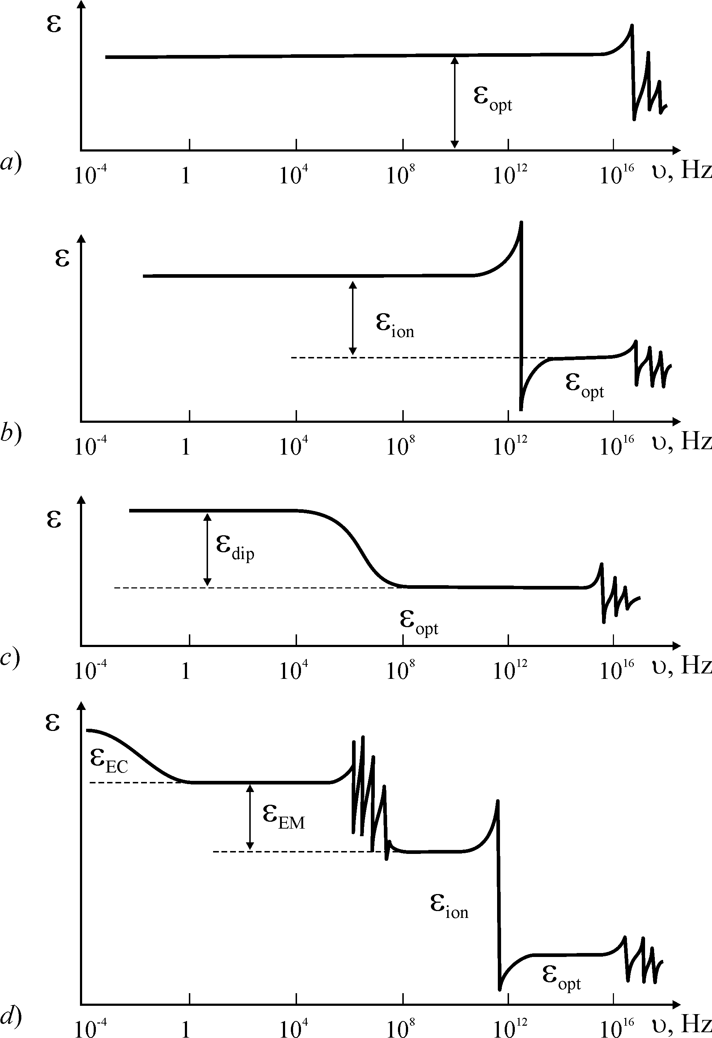

Fig. 2.5. Dielectric spectra of different dielectrics, and contributions to ε from different polarization mechanisms: ε_{opt} – electrons displacement; ε_{ion} – ions displacement;
ε_{dip} – dipoles thermally activated orientation; ε_{EM} – electromechanical polarization;
ε_{EC} – electrocaloric polarization

Ionic elastic polarization (relative shift of cationic and anionic sub-lattices of crystals) entirely responds at the microwaves, but ionic polarization has a resonant ε-dispersion in the infrared frequency range, Fig. 2.5, b. Ionic polarization determines the dielectric contribution ε_{ion}, which may be measured at the microwave frequencies.
Dipoles thermally activated orientation is a specific polarization mechanism for polar dielectrics. As against to electronic and ionic polarization (which need no thermal activation) the dipoles, a rule, can be oriented by the electrical field with a support of chaotic thermal movement in the dielectric. That is why dipoles orientation is a relatively low-frequency polarization mechanism with the contribution ε_{dip} that leads to the relaxation dispersion, usually below the frequency of 10⁸ Hz. (Fig. 2.5, c). In principle, the only these three mechanisms of the polarization entirely correspond to a microscopic Lorentz model.
Most of comparatively low-frequency and radio-frequency measurements of the dielectric constant are provided by determining of the capacitance of electrical capacitor prepared from studied material. The capacitance is calculated from the value of the reactive electrical current emergent due to the "electrical displacement" of electrical charges under the influence of applied alternating voltage.
However, in the accepted definition of the ε (from capacitance measurements), some uncertainties may occur:

1. Under the influence of electrical field on the non-central symmetric dielectric (piezoelectric) part of the "reactive" (returned) energy can be stored in a mechanical form (that is in the form of elastic deformation of the entire sample of piezo-active dielectric). It should be noted that the method of ε-determining by the measure of the capacitance does not allow to separate the reactive current emergent due to the piezo-mechanical deformation of the sample as a whole from the reactive current conditioned by the microscopic mechanisms of the electrical polarization in the same dielectric. That is why, the concept of electromechanical dielectric contribution should be introduced, and it looks as the ε_{EM}, Fig. 2.5, d.

2. In the polar dielectric (pyroelectric or ferroelectric), the energy can be partially reserved in the form of a heat (electrocaloric effect). In the case of pyroelectric capacitor measurements, it is impossible to distinguish the contribution from the pyro-accumulated energy from the reactive energy stored by other mechanisms of polarization, and this electrocaloric dielectric contribution in the Fig. 2.5, d is designated as ε_{EC}.

It is obvious that both of these effects, being measured through the value of the reactive current, do not meet the definition of Lorentz dielectric permittivity as a parameter for the physically infinitesimal volume. Dielectric contributions ε_{EM} and ε_{EC} obtained even at the same frequency of measurements (but using test samples of significantly different size) might be quite different. The point is that the manifestation of the piezoelectric or pyroelectric effects strongly depends on the shape and geometry of a test sample, which are significantly determined by both of mechanical and thermal conditions, at which capacitor consisting of piezoelectric or pyroelectric material is studied.

3. Many materials that are widely used in the electronics use the ordered or disordered mixtures of different dielectrics, as well as the mixtures of dielectrics with dispersed semiconductors or conductors. The measured electrical capacitance of the capacitor inclusive such a mixture might be many times larger, that is again attributed to the increase in the “seeming permittivity". In some cases, this is the additional electrical polarization (Maxwell-Wagner mechanism for mixtures), which is caused by the accumulation of a space charge at the boundaries of components of a mixture, or space charge in the near-to-electrode regions.
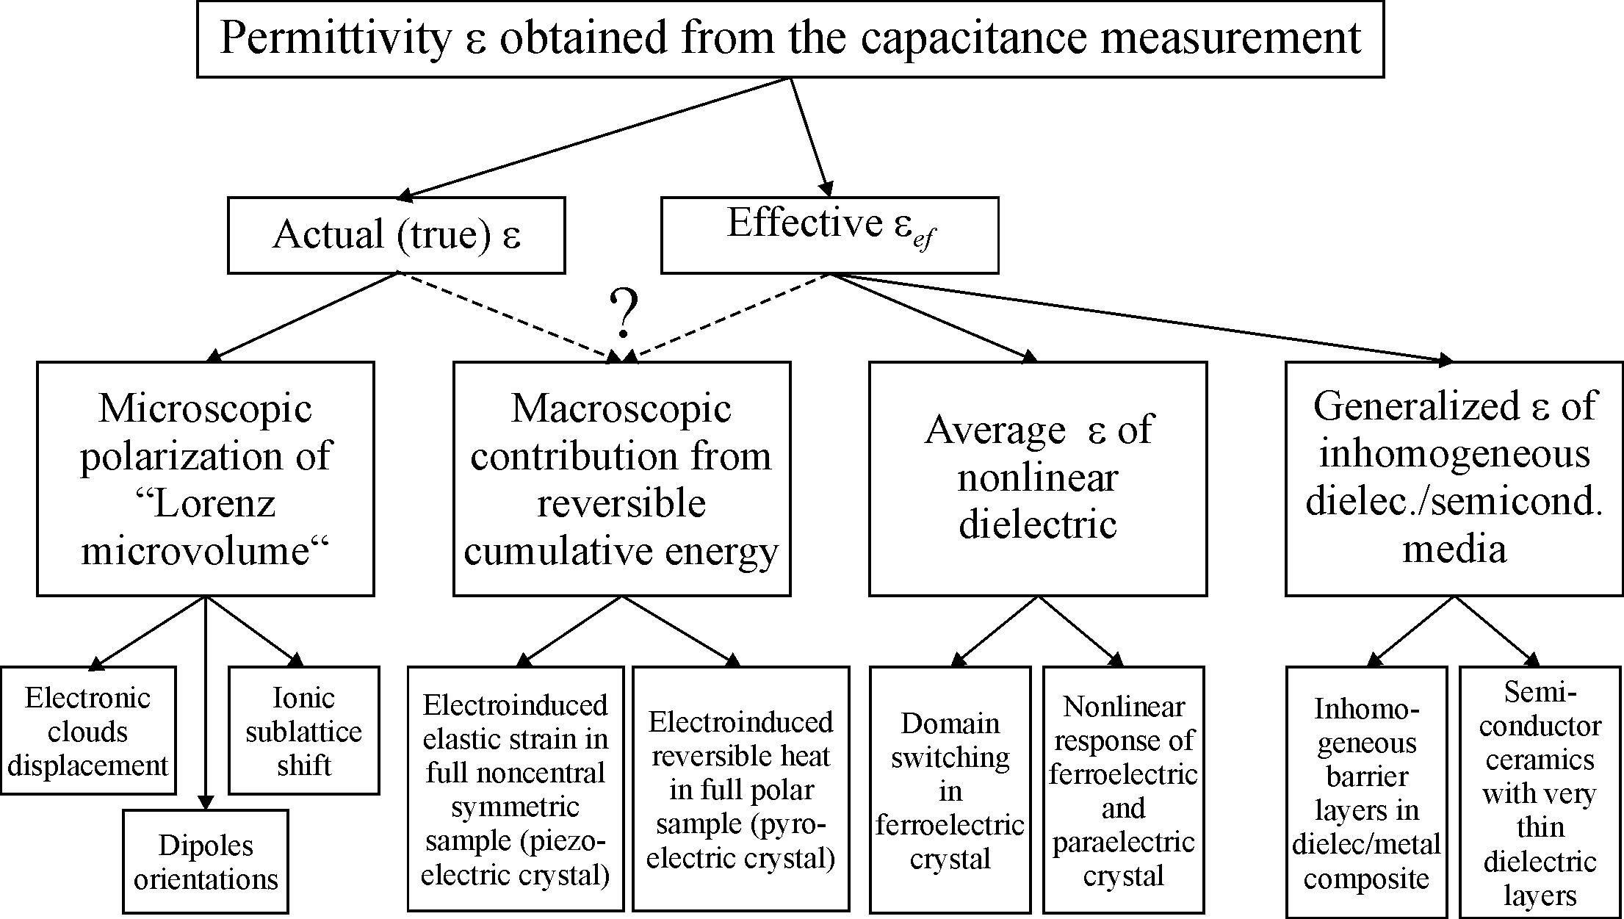

Fig. 2.6. Possible classification of dielectric contributions from various polarization mechanisms

In the description of the dielectric constant of such inhomogeneous materials a concept of "effective" dielectric constant is used commonly. The value of ε_{migr} = ε_{ef} in the case of macroscopic Maxwell-Wagner polarization does not meet the definition of ε given as a microscopic Lorentz parameter. The ε_{migr} usually is characterized by the relaxation type frequency dispersion located in the frequency interval of 10^{‒3}…10³ Hz (in the Fig. 2.5 the frequency dependence of ε_{migr} is not shown).

4. In the nonlinear dielectrics (ferroelectrics and paraelectrics), the direct proportionality of the reactive current to the applied voltage might be violated. For example, while repolariztion of spontaneous polarization in ferroelectrics the value of apparent permittivity changed in many times, sometimes reaching the values ​​of the order of 10⁵ (depending on the instantaneous values ​​of the alternating electrical field). In this case, it is also possible to use the terminology of "effective" (non-Lorentz type) dielectric constant.

All these cases are indicated in the Fig. 2.6, where various dielectric contributions from different polarization mechanisms are divided into two classes. Dielectric permittivity that is due to the "classical" mechanisms of polarization and satisfies the definition of Lorentz is called as an actual ("true") permittivity in order to distinguish it from the conventional term of the "effective" permittivity. The fact that in the case of capacitance increasing in the electrical capacitor that contains the heterogeneous mixtures can be characterized only by the effective parameter ε_{ef} seems to be obvious. By the same way, the nonlinear polarization of a ferroelectric material that is characterized by the average permittivity might be also described by the effective parameter ε_{ef}.
As it follows from the dielectric spectra shown in Fig. 2.5 and from the classifications given in Fig. 2.6, in the microwave dielectrics, the only two polarization mechanisms are important: the displacement of the atomic electronic shells and ionic sub-lattices electrically induced displacement. Other polarization mechanisms are too slow to have an influence onto ε_{mic} but they can add to the microwave dielectric losses.

In the homeopolar (atomic) crystals with the structure of diamond (C, Ge, Si), as well as in the centre symmetric molecular crystals (with has no the structural dipoles), the dielectric constant is defined only by the electronic elastic polarization. This mechanism of polarization is practically non-inertial and its contribution ε_{el} = ε_{opt} can be measured as on the optical frequencies; therefore, in the entire frequency range used in the electronics the dielectric constant of such crystals is not frequency dependent.
In the molecular crystals, which structure has dipole-like structures, except electronic shells polarization, the lower-frequency polarization is added as a contribution from the thermally activated polarization of dipoles (Fig. 2.5, b). In this case, the dipoles are not considered as the impurities but they belong to the basic structure (for example, in the ice crystal). While frequency dispersion of the permittivity, the dipoles polarization contribution ε_{dip} gradually decreases. This character of the dispersion is called as relaxation.
In the ionic crystals, the ionic elastic polarization is added to the always existed electronic (optical) polarization. This mechanism of polarization is also a high-frequency one, and the ε-variance is observed in the infrared frequency range (~10¹³ Hz, Fig. 2.5, c). Therefore, ionic polarization contribution is indicated as ε_{ion} = ε_{IR}. Dielectric dispersion in this case, as opposed to the relaxation dispersion, shows the ε_{ion} resonance as the frequency approaches the natural frequency of the ionic lattice vibrations; parameter ε(ν) first increases and then reaches a maximum, after it drops sharply, sometimes to the negative values. The nature resonant dispersion will be explained later in Section 3.3.

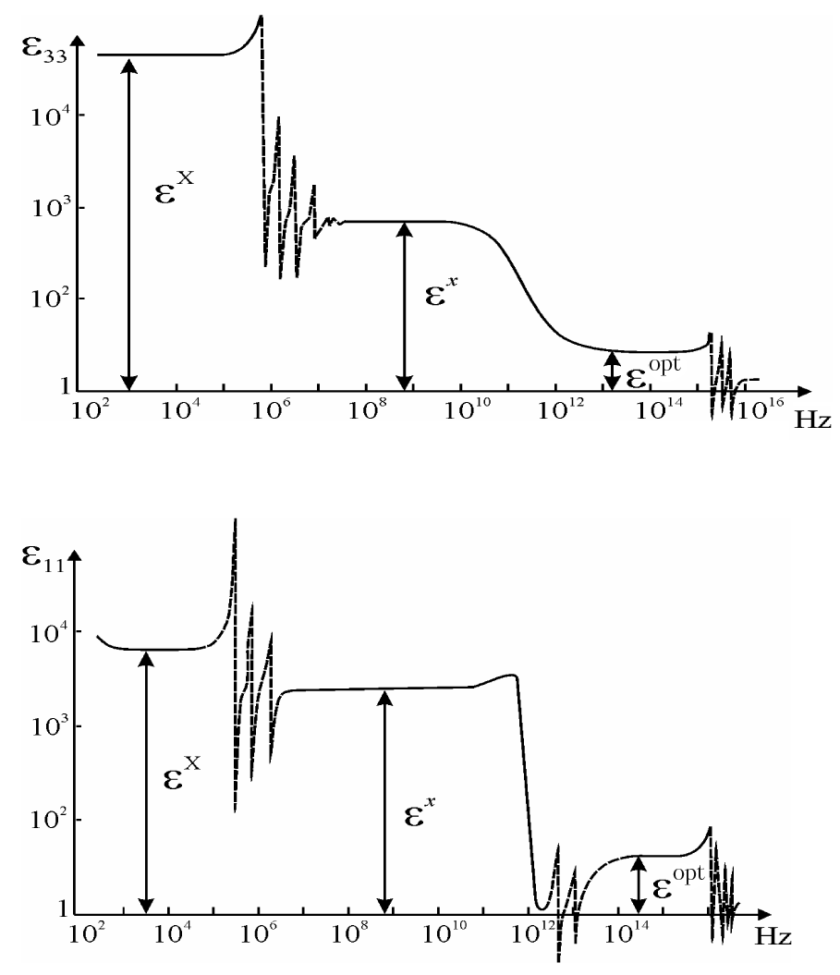

Fig. 2.7. Examples of dielectric spectroscopy method application for analysis of various contributions to permittivity: in a single-domain crystal of barium titanate piezoelectric resonant dispersion occurs at a frequency of about 1 MHz, and lattice dispersion in IR region (about 10¹² Hz); potassium dihydrogen phosphate also has a piezo-dispersion, and dipole relaxation in microwaves, near in 10¹¹ Hz

In the Fig. 2.5, the theoretical frequency dependences ε(ν) were depicted, but Fig. 2.7 illustrates frequency characteristics of well studied crystals – barium titanate BaTiO₃ in its ferroelectric phase, and potassium dihydrogen phosphate KDP near Curie point. In single crystals of barium titanate at temperature 300 K the electromechanical contribution ε_{EM} is approximately equal to all other (higher frequency) contributions from polarization mechanisms: at low frequencies ε^{X} ~ 4000, and, after piezo-resonances, the lattice contribution is ε^{x} = 2000. In the KDP crystals at temperature 125 K the piezoelectric contribution ε^{X} almost in 100 times greater than the contribution of all other mechanisms (dipole and optical).

2.3. Electronic (optical) polarization

Electronic quasi-elastic polarization is a general mechanism of electrical polarization. In an external electrical field the electronic shells of atoms (molecules or ions) displace relative to positively charged nuclei (cores). Since the mass of the nucleus in 10⁴…10⁵ times exceeds the mass of electron, this polarization adds up to a shift of electrons. Therefore, the main contribution to the induced electrical moment is given by the comparatively weakly bounded electrons of the outer shells of atoms or ions, especially by the valency electrons. They are displaced in the electrical field to much greater extent than the strongly bounded core electrons of the atom or ion.
For the quasi-elastic electronic polarization, the most important are following two features. Firstly, this is an universal mechanism of polarization, since the deformation of the electron shells of atoms or ions in the electrical field occurs in all matters. Secondly, it is the least inertial polarization mechanism, since the mass of the electron is much smaller than the mass of other particles (atoms, ions or molecules) involved in the processes of polarization. Quick settling allows select the electronic polarization experimentally using its contribution to the permittivity at the optical frequencies: ε_{e} = ε_{opt} = n². This contribution can be defined by means of optical refractive index n measurement. As it should be found from the Maxwell equations, n = (εμ)^{1/2}, but at optical frequencies μ = 1, so ε_{opt} = n².
The time of the electronic elastic polarization settling is estimated as τ = 10^{‒16}…10^{‒17} s. The visible optical frequency range is close to the value of 10¹⁵ Hz, so the delay of electronic polarization (that determines frequency dispersion of ε_{opt}) should occur at higher frequencies than the visible optical range.
To simplify the calculations, the only basic understanding of the mechanisms of polarization will be considered. Therefore, the calculation of the electronic polarizability of the electronic shell α_{e} is exemplified for the hydrogen atom, and using the simplest Bohr's model.
Electrical charges of the proton and electron are 1.6∙10^{–19} C (Coulomb), the mass of proton is т_{р} = 1.67⋅10^{–24} g, while the mass of electron is т_{е} = 9.11⋅10^{–28} g, that is in 1840 times less. According to the Bohr model, the electron revolves around the positively charged nucleus at a distance r_{e} = 0.53 Å = 0.53⋅10^{–10} m. The electric field between electron and proton equals Е_{r} = 5⋅10¹¹ V/m. In the absence of the external electrical field the effective center of negative charge coincides with the center of positive charge, Fig. 2.8, a.
Under the action of local (microscopic) electrical field F (descending from externally applied macroscopic field E), the electronic shell of the atom is displaced, so the geometrical center of the negative charge is moved on a distance x from the center of positive charge (Fig. 2.8, b). Correspondingly, the electrical moment p = qx is induced, which is proportional to the applied local field: p = α_{e}F = qx, where α_{e} is the electronic polarizability which need to be calculated. From presented model, it follows that α_{e} = 4πε₀r³, where r is Bohr model electronic radius, and the factor 4πε₀ is required to record the polarizability in the SI system; so the dimension of polarizability is [α] = F⋅m³.

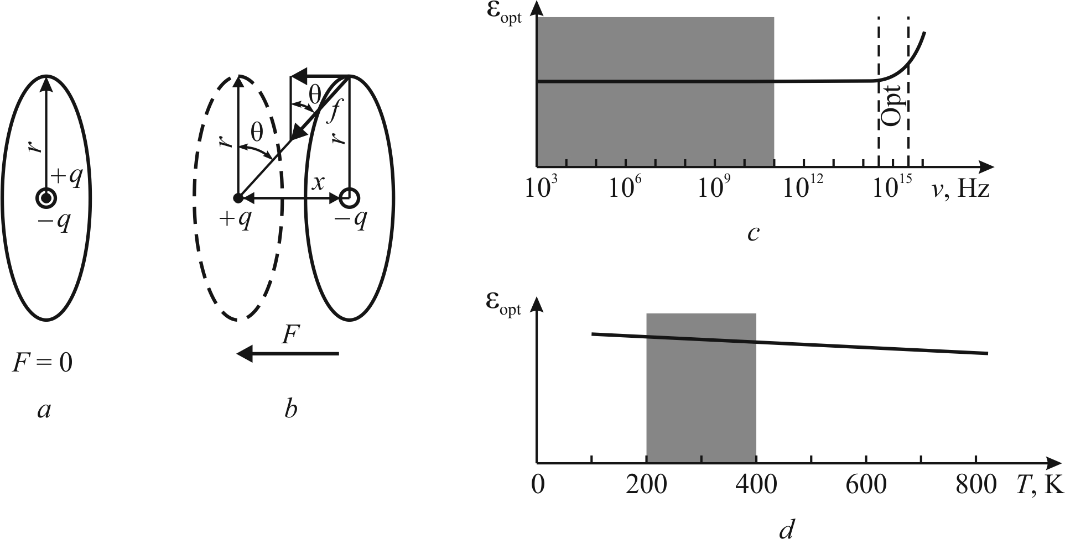

Fig. 2.8. Simplified model of electronic (optical) polarization: a – simplest model consisting of one electron and nucleus; b – orbital deformation in local field F; c – frequency dependence of electronic permittivity; d – temperature dependence of electronic permittivity.
Shaded areas show the range of technical interest

The balance of proton-electron connection under the influence of the electrical field F is ensured by the equality of the perturbation force f_{per} = qF and the return force f_{ret} = cx which is proportional to the deformation x that tends to restore the non-polar state: f_{per} = qF = cx = f_{ret}. From these equations, it follows that electronic polarizability equals α_{e} = q²/с.
The coefficient of "elasticity" c in this model can be found by clarification the physical nature of a restoring force, which is a constituent part of the Coulomb attraction forces (Fig. 2.8, b): f_{ret} = f sinθ.
Since f = q²/4πε₀(r² + х²) аnd sin = х/(r² + х²)^{1/2}, it follows that

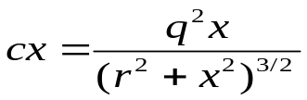. (2.9)
Due to the fact that field F is relatively small (F << Е_{r}), the elastic displacement x << r, and the more x² << r². Therefore, the coefficient of "elasticity" is: с = q²/4πε₀r³. Substituting this value into the formula for the electronic polarizability, it can be obtained
α_{e} = 4πε₀r_{e}³, (2.10)
where r_{e} is Bohr-model electronic radius, the factor 4πε₀ is required for the recording of the polarizability in the SI system, that provides the dimension [α_{e}] = F⋅m³. However, for the comparative analysis of electronic polarizability it is more convenient to estimate the relative parameters α_{e rel} = α_{e}/4πε₀, where electronic polarizability is defined as α_{e} _{rel} = r_{e}³.
It is known that Bohr's model is an approximation: in fact, the electronic cloud is not localized on the sphere of radius r_{e} but constitutes a diffuse cloud around the proton. The exact quantum-mechanical calculation yields the value of the polarizability α_{e} = 18πε₀r³ which is 4.5 times more than the calculation obtained from a simple model. This discrepancy can be explained by the fact that the quantum-mechanical model of the electron cloud is more "extended". Obviously, the more remote parts of the electronic cloud are associated with the nucleus much weaker, and therefore they significantly increase the polarizability, which is largely (in cubic law) depends on the distance from the nucleus of the electronic charge.
Nonlinear susceptibility in strong electrical fields. To evaluate the nonlinearity of the susceptibility in the strong electric fields, its dependence on the effective electric field F can be represented as a series

α′_{e rel} (F) = α₀ + α₁F + α₂F² + α₃F³ + …, (2.11)

which coefficients can be found from the aforecited expressions qF = cx and cx = q²x(r² + x²)^{–3/2}, but under the condition that the smallness of x compared to the radius of the electronic orbit r can not be ignored. It means that

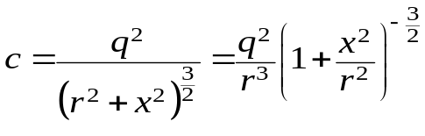. (2.12)
Thus, with the increase of external electric field the electron orbit moves away from nucleus, so the Coulomb force of electron’s attraction to nucleus decreases, and, as a result, the polarizability α′_{e rel} increases. From equation (2.12) the dependence of the polarizability of the field can be represented as a series that converges rapidly to the parameter х²/r²:
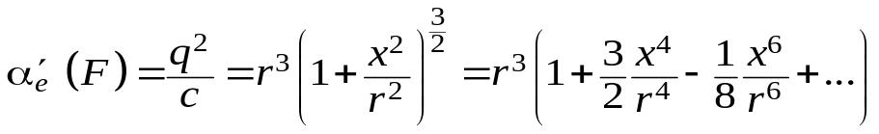.
The orbital extension x, induced by the field F, is proportional to the field tension: х = qF/с, so this expression should be substituted in the series (2.11), and then be compared with the series (2.11). As a result, the coefficients in the equation (2.11) can be found with the following values:

α_{0 rel} = r³, α₁ = 0, 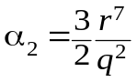; α₃ = 0, 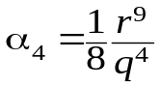, α₅ = 0. (2.13)

In the series (2.11) it is sufficient to find the first non-zero coefficient (after main value α_{0 rel}), since the nonlinearity is noticeable only in very strong fields. All coefficients at the odd degrees of F equal to zero (this might be expected in the symmetrical model), so the nearest non-zero coefficient is positive: α₂ > 0. It signifies that in the strong fields the polarizability α_{e}(F) increases and, consequently, the dielectric permittivity also should be increased.
This non-linearity occurs because the force which returns the system to the unpolarized state (force of attraction of the electron to the nucleus) is reduced according to the law (r² + x²)^{–1}, while the distance dependence on acting electric field is a linear. The orbit of the electron is stretched, and, therefore, the polarizability α_{e} increases with electric field growth. In this case, the change of the electric field direction, due to the symmetry of the selected model (Fig. 2.8) has no influence on the polarizability.
The increase of polarizability with the electric field grows, respectively, leads to an increase of ε_{opt} = ε_{e} and hence the refractive index n in a strong electric field at light frequencies must increase. This lens-effect is indeed the case, and it is used in the nonlinear optics for focusing in the dielectric high-power laser radiation.

Discussing the results obtained for the electron polarization in the linear case, it should be noted that the electronic polarizability of the hydrogen atom is proportional to the cube of the radius of the electron orbit. This means that the polarizability increases rapidly with increasing distance from electrons to nuclei. For this reason, the above fulfilled calculation of atoms (or ions) polarizability is sufficiently accurate approximation to consider only the external electronic shells of atoms or ions. Thus, the quasi-elastic electronic polarizability actually is proportional to the volume of atoms or ions. Sizes of atoms are of the order of 10^{–10} m, so the value of the polarizability α_{e rel} of electronic shells of atoms or ions is of the order of 10^{–30} m³.
Despite the simplicity of the discussed model, the calculation of the polarizability of the hydrogen atom leads to important conclusions about polarizability of others atoms and ions. From the obtained formula, it follows that the electronic polarizability of various chemical elements belonging to the same group (i.e., located in the same column of the periodic table), should increase with atomic number increasing. The fact that the total number of electrons increases as well as the radius of the outer electronic shell (which has a similar structure). Indeed, such a pattern occurs. For example α_{e rel} increases in the series of halogens F, Cl, Br and I, where the α_{e rel} is respectively: {0.4, 2.4, 3.6, 5.8}×10^{–30} m³. Thus, if the electronic structure of outer shell is similar, the polarizability increases with increasing of the element atomic number (located in the same column).
However, while atomic number increasing for the elements located along the period (i.e., along the line) of the periodic table, the electronic polarizability of atoms can both increase and decrease depending on what prevails: the effect of number of electrons increasing or the effect of increasing nuclear charge, which leads to a decrease in the radius electron shell. For example, polarizability of elements with atomic numbers from 6 to 9 (C⁶, N⁷, O⁸ and F⁹) fluctuate as (0.94, 0.96, 0.64, 0.4)×10^{–30} m³.
For most dielectrics, which are chemical compounds, the greatest interest is not a polarizability of atoms but polarizability of ions. It is these data that allows estimate the electronic polarizability of various chemical compounds (without any complex optical and high-frequency studies). The polarizability of ion is compared with the ionization potential – the energy that needs to add an atom or ion to the detachment of the electron located on the outer orbit. The larger ionization potential, the stronger is the coupling of the electron with the nucleus, and the less is the electronic polarizability. Using the values of the ionization potential it is possible to estimate the electronic polarizability.
For the negative ions that accept electrons in the outer shell, the polarizability should be much larger than for the positive ions that give away the valence electrons. As already noted, the polarizability of the positively charged ions is less than the negative, and less than for the neutral atoms with a similar electronic shell. Thus, among the series О^{2–}, F–, Ne, Na⁺, Mg²⁺, A1³⁺ and Si⁴⁺ the value of α_{e rel} decreases. In all of these ions, the outer electron shell is similar to the shell of the inert gas neon, and has a structure s²p⁶. But the radius of the shell decreases systematically as the nuclear charge is incremented by one, and the attraction of the electrons to the nucleus increases. Therefore α_{e rel} in this series differ by more than an order of magnitude: from the value of 2.4⋅10^{–30} m³ for the ion O² to the value of 0.16⋅10^{–30} m³ for ion Si⁴⁺.
In those materials that have anisotropic structure, electronic polarization is more complicated than in the model shown in Fig. 2.8. Electrical field differently deforms the electronic orbits of different types (which are bounded asymmetrically to the core as well as with each other). However, the assumption of spherical symmetry in the distribution of charges is made to simplify the above calculation that is a good approximation to the structure of the electronic shells of s²p⁶ type. In the formation of the most ions, the electron shells of inert gases are reproduced, so that the model of spherical symmetry can serve as the basis for the majority of the estimated calculations of the electronic polarizability.
The dielectric constant of the material is determined not only by the polarizability but by the concentration of ions or atoms in a unit volume of the dielectric. Therefore, an objective assessment of the electrical moment per unit volume of the dielectric is not a parameter α_{e rel}, but the ratio α_{e rel}/r³ which is equal to one only for the simplest model of the hydrogen atom. However, for the majority of atoms and ions this ratio differs from one. For some ions, such as Li⁺, Na⁺, Mg²⁺ and Al³⁺ the ratio α_{e rel}/r³ < 1, for the majority of the ions this ratio is very close to one, but for ions О^{2–}, Тi⁴⁺, Pb²⁺, Се⁴⁺ the value of α_{e rel}/r³ > 1.
The ability to control the value of the refraction coefficient n = ε_{e}^{½} by the introducing ions into the dielectric with a higher relative α_{e rel}/r³ is used in the integrated circuit technology. For example, to produce planar light guides with the aim of increasing the refractive index, in the surface layer of the glass or crystal the ionic diffusion of Ti⁴⁺ is carried.
The dielectrics, in which the electronic polarization dominates (solid dielectrics with covalent and molecular bonding) are characterized by a small dependence of the dielectric constant on temperature (Fig. 2.8, d) and extremely low value of the dielectric loss, even at high frequencies, because ε_{el} = ε_{opt} does not depend on frequency up to the optical range. That is why, these dielectrics also have a little absorption not only in the optical, but also in all infrared spectrum.
As it is shown in Fig. 2.8, c, the dielectric constant conditioned by the electronic (optical) polarization does not depend on frequency up to optical frequencies, where ε_{opt} gradually starts to increase (in the ultra-violet electronic polarization shows resonant dispersion). In most cases, the electronic contribution to the permittivity somewhat decreases with temperature due to the thermal expansion of a crystal, Fig. 2.3, d. That is why, the temperature coefficient of permittivity is very small and negative (TCε < 10^{–5} K^{–1}, that is less than 10 ppm/K).
Some examples of temperature and frequency characteristics for dielectrics that have only electronic polarization are shown in Fig. 2.9 and 2.10.

Polymers, among dielectrics applied in the electronic occupy an important place. They are used as structural materials and substrates for microwave circuits both in pure form or as a basis for composites filled with particles of solid dielectrics.

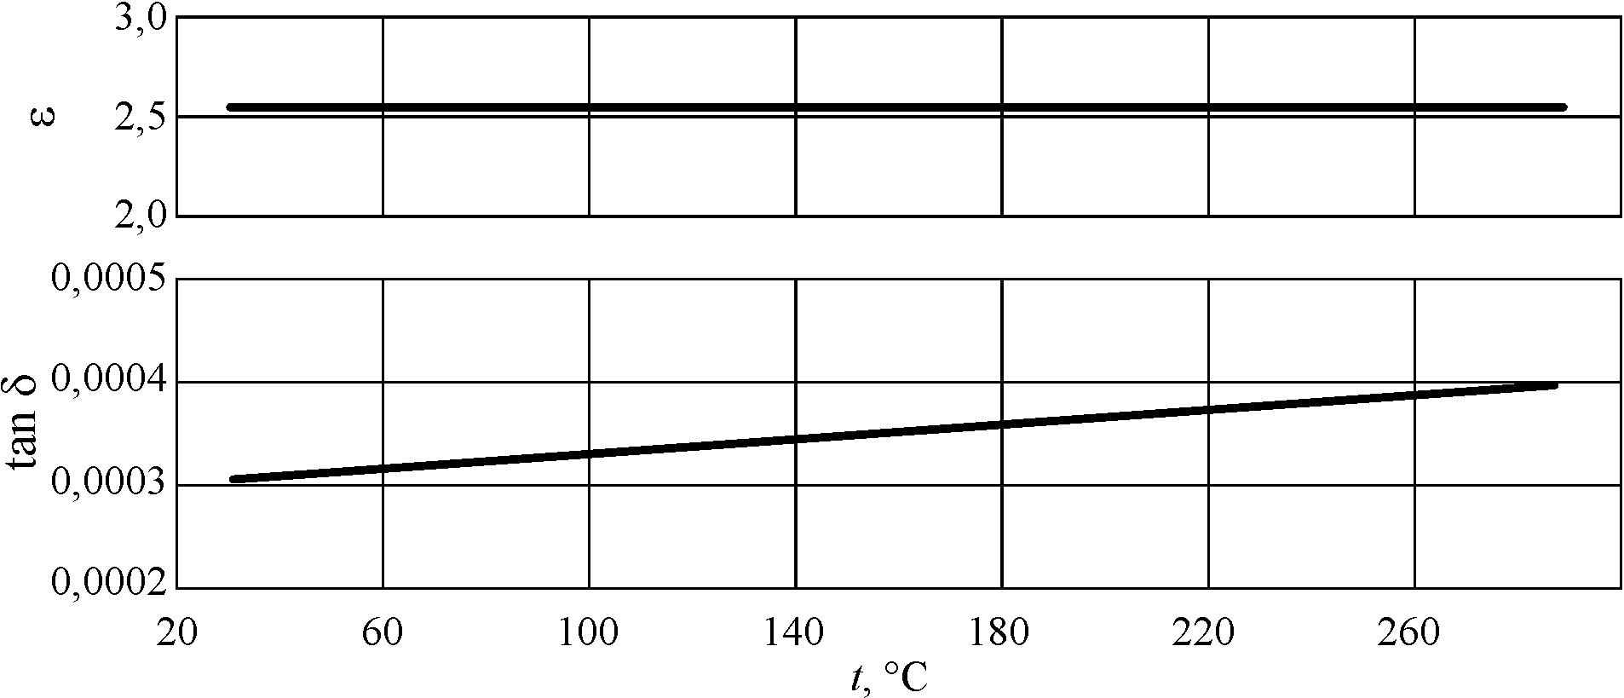

Fig. 2.9. Permittivity ε and loss tangent for polystyrene at frequency 10 GHz
Widely used in microwaves polymers are: Teflon (ε = 2.02, tan δ < 10^{–4}), polyethylene (ε = 2.26, tan δ < 10^{–4}) and polystyrene (ε = 2.54, tan δ = 3⋅10^{–4}). The parameters of these polymers are frequency independent. The temperature dependence is also negligible (Fig. 2.9) because it is determined only by the thermal expansion of polymer.

Semiconductors of diamond structure, such as high-resistive silicon very often are used as microwave dielectrics at the millimetric waves. Since the microwave integrated electronics circuits need the dielectric substrate (in which electromagnetic waves can propagate), it is necessary to consider the dielectric properties of semiconductors.
The nature of permittivity in the atomic crystals of semiconductors (Ge, Si and C) is purely electronic. So the frequency change of ε in these crystals is possible only at optical frequencies (above 10¹⁵ Hz). That is why, in the microwaves, the electronic polarization does not contribute to the microwave losses (which defined only by the conductivity). Therefore, the absorption of microwave energy is more for the low resistance (doped) semiconductor crystals, which is particularly felt in the beginning of microwave range. Due to rapidity of electronic polarization establishing, the semiconductor dielectric constant at microwaves does not change with frequency, Fig. 2.10, a.

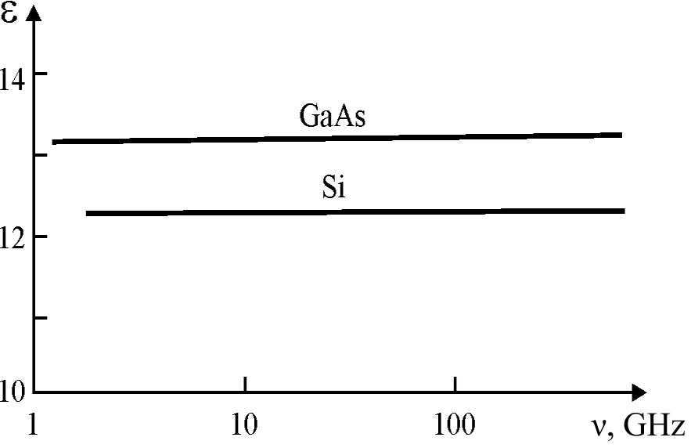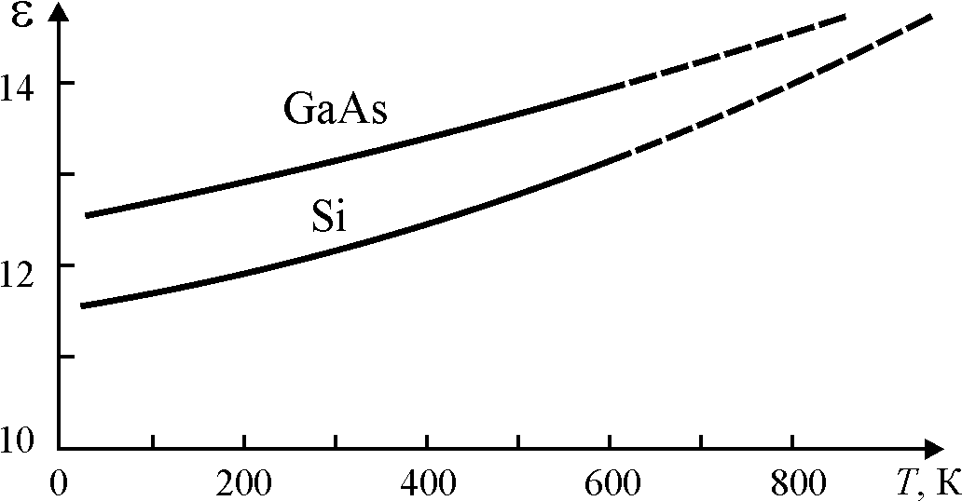

a b

Fig. 2.10. Microwave studies of the dielectric constant of silicon (in comparison with gallium arsenide): a – frequency dependence; b – temperature dependence

Temperature measurements of dielectric parameters in semiconductors are possible only at frequencies above 300 GHz, and these experiments shows a somewhat increase of ε = ε′ with temperature. According to the energy-band theory, when energy-gap is reduced, the permittivity should be greater. As the temperature rises, the band gap of semiconductors decreases; respectively, with rising temperature the ε increases (Fig. 2.10, b).

2.4. Ionic (far-infrared) polarization
The ions (in molecules or in crystal lattice), which are electrically charged particles, as well as the electrons are shifted in the electrical field from their equilibrium position, and this gives rise to an induced electrical moment. In the case of the ion displacement from its equilibrium position the elastic returning force occurs, which, after switching off the external field, quickly returns the system of ions in the undisturbed position.
Ionic quasi-elastic polarization has the following features. First of all, this kind of polarization is not universal for all dielectrics (such as the electronic polarization), and it is a characteristic only for those dielectrics in which ionic character is expressed in the molecules or in the crystal lattice. Typical representatives of the dielectrics, where the ionic polarization plays a decisive role, are alkali-halide crystals (such as NaCl). Quasi-elastic ionic polarization affects also the electrical and optical properties of A^{III}B^{V} semiconductors (e.g., GaAs), and A^{II}B^{VI} (e.g., CdS). However, in the covalent semiconductors (such as Si) the ionic polarization is absent (in them the mechanism of quasi-elastic displacement of the electron shells of atoms is dominating). In the active dielectrics – piezoelectrics, pyroelectrics and ferroelectrics – the ionic polarization is the main mechanism of the electrical response to the applied field.
Another important feature of the ionic polarization is that the settling time of this mechanism is much greater than the settling time of the electronic polarization. This is due to big mass of the ions compared to the mass of the electrons. However, the reaction time of the ionic polarization (~10^{–13} s) is still much smaller than characteristical times of thermal polarization (~10^{–6} s) and, all the more, for space-charge polarization (~10^{–1} s). As mentioned above, using this fact, it is possible to find experimentally the contribution of the ionic polarization in the dielectric constant – to study the frequency dependence of the permittivity ε(ν), Fig. 2.5, b and Fig. 2.11, c. The dispersion of ionic polarization occurs in the infrared frequency range. Therefore, even in the microwave range (MW, 10⁹…10¹¹ Hz), the ionic polarization has enough time to fully install, while the thermally induced and the space-charging polarization late already at a much lower frequency and do not contribute to ε_{MW}.
To calculate the polarizability of ionic quasi-elastic polarization α_{i}, a simple model shown in Fig. 2.11, a might be used. It looks like two-ion molecule, but these ions can represent also the two sublattices – cationic and anionic – inserted one inside the other and forming, thereby, an ionic crystal. This model takes into account only the Coulomb attraction of the ions, as well as repulsive forces arising from the interpenetration of the electron shells. In this model it is assumed that a charge q is concentrated in the centre of the ions, therefore, r = r₁ + r₂ is the distance between the centres of the ions.

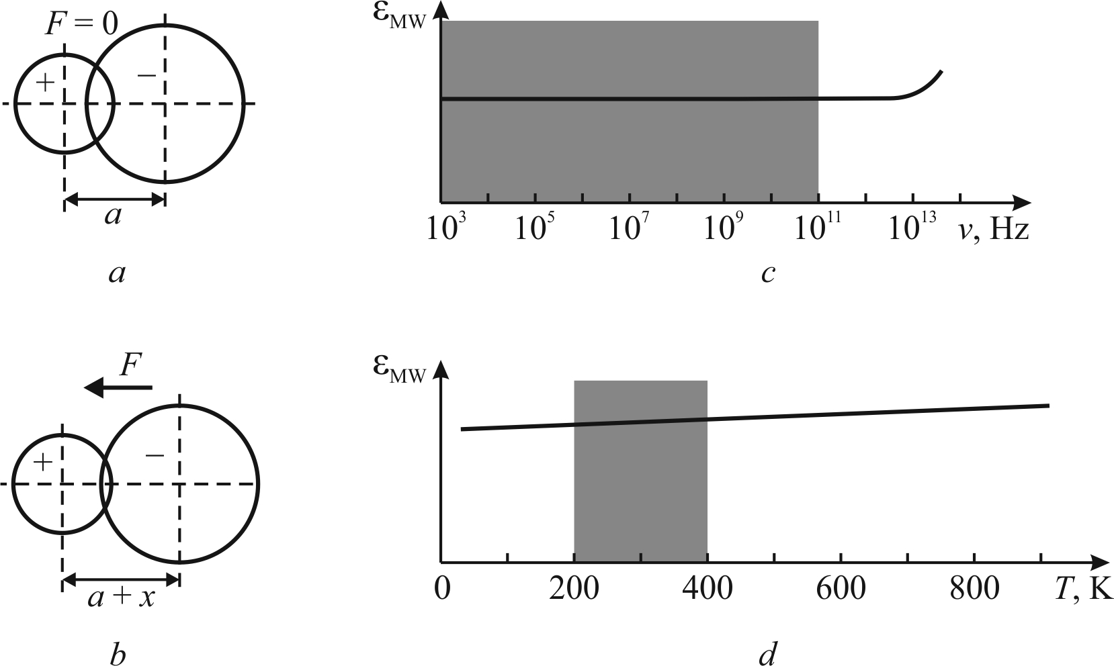

Fig. 2.11. Ionic polarization: a – simplest model consisting of one positive and one negative ion;
b – model deformation x in local field F; c – frequency dependence of ionic permittivity;
d – temperature dependence of ionic permittivity. Shaded areas show the range of technical interest

It follows from the Coulomb's law that the energy of mutual attraction of ions decreases proportionally to the distance between them, and it is q²/4πε₀r. The repulsive energy of electron shells sharply increases only in case of a strong convergence of ions that is described by a power function approximation d/r^{n} where the parameter n ~ 8…11 depends on the properties of a particular pair ions in the crystal lattice.
The coefficient d can be determined from the other parameters of the same model. The total potential energy curve has a minimum, which is characterized by the stability (equilibrium) state of ions: 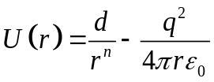. To determine the constant d of the model, it needs to use equilibrium position (at r = a) when force acting on ions is zero, i.e. 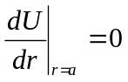, from where: 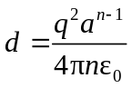. Thus, the interaction energy of the ions is determined by the following expression:

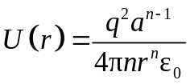 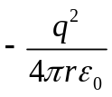.

At mutual displacement of the ions under the acting field at a distance x the returning force arises: –сх, that tries to restore the unperturbed state. This force is equal to stimulant force qF, but its direction is opposite. Hence: cx = qF, and qх = α_{i}F, where is ionic polarizability is α_{i} = q²/c. Thus, the determination of the ionic polarizability meaning is reduced to calculation of quasi-elastic constant c.
Using the dependence of the elastic energy on deformation: U = ½cx², it is possible to find an expression for the energy change when displacement of the ions in the external field: U(а + х) – U(а) = ½ cx³. To determine the value of elastic constant from this model the left and right side of equation: 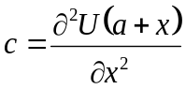 should be twice differentiate. Next it needs to determine the U(a + x). For this purpose, the expression for U(r) is used, in which the r should be substituted by (а + х). Determining the second derivative of the expression obtained, and neglecting in the final result by value x (very small in comparison with the lattice parameter a), it is possible to obtain

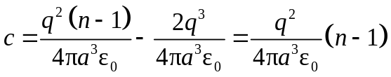,

so the ionic polarizability is
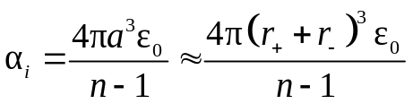, (2.14)

where r₊ and r– are ionic radii while parameter n ~ 10 describes electronic shells repulsion (factor 4πε₀ is required to record the polarizability in the SI system). Since the electron shells overlap is small, the distance between the centres of the ions is almost equal to the sum of radiuses of two ions. Thus, from this model, it follows that the order of the polarizability α_{i} is close to the polarizability of the electronic elastic polarization (α_{е} = 4πε₀r_{e}³, where r_{e} is the radius of the electronic orbital of ion).
As it is shown in Fig. 2.11, c, the dielectric constant conditioned by the ionic polarization does not depend on frequency up to the far infrared range, where ε_{i} = ε_{ir} gradually starts to increase (in the far infrared range the ionic polarization shows a resonant dispersion).
In most cases the ionic (lattice) contribution to the permittivity somewhat increases with temperature due to thermal expansion of crystal, Fig. 2.11, d. The question is that at higher temperatures the distance between ions increases, so their reciprocal elastic shift in the electrical field (elementary polarization) becomes bigger. Due to this, the permittivity thermal coefficient in the ionic crystals is positive TCε < +10^{–4} K^{–1} that means +100 ppm/K).

Table 2.1.

Ionic crystals permittivity measured at microwaves in comparison to optical polarization contribution

Alcalinehaloid crystals |  |  | Ionic crystals
 | ε_{mic} | ε_{оpt} |  | ε_{mic} | ε_{оpt}
LiF | 9.3 | 1.92 | SrF₂ | 7.7 | 2.08
NaCl | 5.6 | 2.25 | ZnS | 8.3 | 5.07
NaBr | 6.0 | 2.62 | CaF₂ | 8.4 | 1.99
KCl | 4.7 | 2.13 | MgO | 9.8 | 2.95
КВг | 4.8 | 2.33 | CuCl | 10 | 4.57
RbCl | 5.0 | 2.19 | CaO | 11.8 | 3.28
RbBr | 5.0 | 2.33 | SrO | 13.3 | 3.31
CsCl | 7.20 | 2.60 | TlBr | 31 | 5.41
CsBr | 6.51 | 2.78 | TlC1 | 32 | 5.10
AgCl | 12.3 | 4.01
AgBr | 13.1 | 4.62

However, in many cases, especially for the thallium salts, the ionic (far infrared) dielectric contribution much exceeds the electronic (optical) contribution to permittivity. This may be explained in the more complicated but more accurate dynamic model that will be discussed later in the Section 3.3.

Nonlinearity of ionic polarization is possible to estimate in the same manner, as in the case of the electronic polarization. In the nonlinear case, it can not be considered that the relief of the ionic potential is described by a simple parabolic function, and the restoring force is proportional to the strain. For the first coefficients of series that describes the nonlinear properties of the polarization mechanism it can be assumed
α_{і}(F) = α₀ + α₁F + α₂F² + …

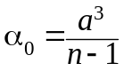; 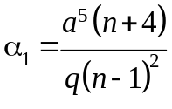 … (2.15)
Comparing this result with α_{e}(F) coefficients for non-linear electronic polarization (2.13), it should be noted that for this model already odd coefficients (α₁) is nonzero, so no need to take into account next even coefficient (α₂). This means also that a potential well, which characterizes this model, is the asymmetric one.

Next, the question of how ionic elastic polarization becomes apparent in a variety of dielectrics will be we considered. An important experimental evidence of the ionic polarization presence in dielectrics and semiconductors is the far-infrared (IR) dispersion of the dielectric constant. It becomes apparent in the fact that the quantity of ε_{ir} first increases (as far as measurements is close to frequency of the dispersion), and then decreases sharply, Fig. 2.5, a. In the IR region spectrum it is also observed the absorption, that is significant in the ionic semiconductors with mixed ionic-covalent bond, and much more for "purely ionic" crystals. In the latter case, the absorption in the region of ε_{ir} dispersion is so great that the quantitative results for the determination of the parameters of the dispersion can be obtained only in the study of the reflectance spectra.
In crystals with domination of Van der Waals forces between atoms and molecules (in molecular crystals) the infrared absorption is virtually nonexistent. This means that the ionic polarization is not essential. In crystals with predominantly covalent bonds, for example, in semiconductors with diamond structure (C, Ge and Si), it is possible to notice a very little absorption in the far-infrared range. In pure single crystal of germanium this infrared absorption is observed in the frequency range near of 1.1∙10¹³ Hz. In the high purity silicon crystals weak IR absorption can be seen in the frequency range of (1.3...4)∙10¹³ Hz with maximum at a frequency 1.8⋅10¹³ Hz. In the diamond crystals the frequency of the maximal absorption even higher: 3⋅10¹³ Hz, and the magnitude of the absorption is significantly less than in crystals of Ge and Si. In all these cases, the maximum of the absorption coefficient at a thousand times less than in the typically ionic crystals such as NaCl, but nonetheless a weak infrared absorption in the homeopolar semiconductor crystals still exists. The experiments show that this absorption increases with increasing temperature.
In principle, in the ideal crystal of a diamond type the basic lattice vibrations are not active with respect to the infrared radiation. Therefore, the infrared absorption indicates that the atomic bonding in such crystals are not "purely covalent", but the bonding is partially ionic (just as in the NaCl-type crystals bonding is not purely ionic). Even in the structures of diamond type a such redistribution of electronic charge density is possible, which creates a relationship similar to the ionic bonding. This bonding occurs due to thermal fluctuations and it is stronger the higher is the mean square displacement of the atoms from the lattice sites. Therefore, this type of infrared absorption depends on temperature.
In the crystal lattice spectrum of the A^{III}B^{V} semiconductors the optically active modes in the infrared range are expected. In these compounds, the "ionicity" and the IR absorption is much higher than in semiconductors of a diamond structure. However, in the crystals of A^{III}B^{V} class the ionic polarization contribution to the dielectric constant are much smaller than in the alkali halide crystals. In semiconductors of this class the value of ionicity is characterized by a dielectric contribution Δε_{ion}, which is the greater when band gap the wider. For example, in the InSb crystal the band gap is W = 0.17 eV and Δε_{ion} = 1.4, while in the InP W = 1.3 eV and Δε_{ion} = 3.7. The value of Δε_{ion} is determined according to microwave and optical measurements: Δε_{ion} = ε_{MW} – ε_{opt}.
The data presented as to IR polarization of semiconductors once again suggest that in the real crystals a mixed bonding always has place. Strictly speaking, all discussed above types of bonding (molecular, covalent, ionic, hydrogen, metallic) are the idealized models of real phenomena occurring in the material.
A simple model of quasi-elastic ionic polarization shown in the Fig. 2.11 may be improved by the method of accounting the "polarizability of the ions".

Electronic shell model of infrared polarization. In the previous discussion, the dielectric properties of ionic crystals were analyzed following the model of solid (“hard” or non-polarizable) ion, whose charge is located in its centre. It was believed that such ion moves in the electrical field as a whole, and its electronic shell is not deformed. This model describes the dielectric properties and the infrared spectra of the alkali-halide crystals, especially in those cases where the radii of anion and cation are close in their value (K, Rb and Cs in combination with F, Cl, Br and I).
However, already for the Na-haloids one can observe some difference in the theoretical calculations of the permittivity from experimental data. Further, for the haloids of Li, which has small ionic radius, the theory based on "hard" ion conception leads to the results that do not coincide with the experimental data. For example, for the LiF crystal experimental data is ε_{mic} = 10, but from the solid ion model calculations is expected in microwaves ε_{mic} = 8. An even greater discrepancy occurs when try to apply a simple dynamic theory, based on the model of the solid ion, to describe the properties of thallium haloids. In the case of ТlВr, for example, according to the solid ion simple theory ε_{mic} = 11, but experimental data gives ε_{mic} = 30.
Besides alkali haloids crystals and other relatively simple structures (such as sulphides like ZnS, fluorite crystals like CaF₂, simple oxides of MgO type), there are another crystals, related to the ionic crystals, which have abnormally high microwave permittivity. These crystals include rutile (TiO₂) with ε_{mic} ≈ 100, perovskite (CaTiO₃) with ε ≈ 130, strontium titanate SrTiO₃ (ε ≈ 300), etc. In these dielectrics, except the ionic bonds, covalent bonds between ions play significant role. Unlike simple ionic crystals, in which permittivity temperature coefficient TCε > 0, in these dielectrics this parameter is negative: TCε < 0, and it has very big absolute value. Lattice dynamics theory that will be discussed in Section 3.4 can explain these peculiar properties of paraelectric crystals (as well as the properties of ferroelectrics) using the model of the polarizable ("soft") ion.
The general principles of molecular physics assume that the electronic shells of the ions can be deformed. In crystals there is a partial overlap of the electronic shells of the neighbouring positive and negative ions, which creates a repulsive force for ions. When the distance between ions changes (due to crystal polarization in the external electrical field) the overlap of the electronic shells results in the redistribution of their electrical charges. This should have influence on the repulsive force of the ions: internal frequency of lattice oscillation decreases that, ultimately, affects the dielectric constant value.
In the model of the polarizable ("soft") ion, during electrical polarization, the "core" (i.e. the actual nucleus of the atom and its surrounding by the deep electronic cloud) almost did not change their position. However, the outer shell (both for positive and, especially, for negative ions) holds a relative freedom, and moves in accordance with the applied electrical field. Obviously, the shell of the negative ion feels much larger shift because polarizability of negative ion is much larger than polarizability of positive ion. Due to the unequal offset of shells, their overlap is changed (this overlap always exists, and provides the force of repulsion of the ions). At this, the electronic charges of ions redistribute.
The main distinction of “shell” model from the model of the "hard" ion is that in the case of transverse optical mode the cores (nuclei centers) vibrations of the polarizable ions do not coincide with the centers of the shells. By this reason, the interaction forces between the ions would be different than in the case of model of the "hard" ions. This significantly affects the dielectric properties of crystals.
The "shell” model regards very little to the optical polarization of crystals because such a polarization is characterized by the internal shift between the core and shell of each ion. However, the ionic (far-infrared) polarization of crystals is now described by several mechanisms: as a displacement of the core and their outer electronic shell with the certain degree of autonomy. Therefore, during calculation of the polarizability, one must consider not only the interaction of cores with each other, but also the interaction of the core of a given ion with another ion electronic shell, and finally, the interaction between the shells. While lattice dynamics construction in the case of "soft" ions, it is necessary to assume that the unit cell even for simple alkali halide crystal does not consist of two units (as in the "hard-ion" model) but of the four particles – two cores and two shells.
From the model of the "polarized" ion it becomes apparent that more correct for the elastic polarization, arising in the ionic crystals, it is better use the term “infrared polarization” (but not the term “ionic polarization”). Indeed, the mechanism of this polarization consists not only in mutual displacements of the ion cores, but also in shifts of their outer electron shells. Effective mass of the electronic shells are extremely small as compared to the masses of ions, so at rapidly change of external electrical fields the polarization is formed by the inertia of the cores displacements (electrons always have time to shift after the displacements of the core).
Therefore, despite the fact that the polarization is originated largely due to the displacement of the electrons, the frequency characteristic of infrared polarization mechanism is defined by the elastic forces and the mass of the ions, and, therefore, the resonant frequency should be much less than the visible optical frequency. Moreover, the electronic displacements influence consists in the reducing of the infrared dispersion frequency. The question is that short-range repulsion force between the ions mainly depends on the interaction between ions of adjacent shells, and in the case of "soft" shells the repulsive forces are less than for “hard” ions. If the crystal structure is such that the elastic repulsive forces are reduced, the contribution of infrared polarization might be very large.
Since the so-called ionic polarization, in fact, is mainly due to the displacement of the outer electron shells of ions, to obtain high dielectric constant it is important to use as dielectric’s components the particular ions with more mobile and easily deformable outer electron shells.

2.5. Quasi-elastic dipole polarization

Many molecules have their own electrical moment, that is, they are polarized in the absence of an electrical field: in other words, they represent the permanent dipoles. The elementary dipoles are the asymmetrical diatomic molecules. They are formed from the atoms that are characterized by the different affinity to electron (the different electro-negativity): it is the reason that they have an electrical moment. Such a polar molecule is the HCl molecule. Symmetrical molecules, such as H₂ or Cl₂, have no permanent electrical moment, because they are formed from atoms with the same properties.
Polar molecules characteristics as well as polar dielectrics containing such molecules were first described theoretically by P. Debye. Therefore, the unit of measurement of own electrical moment of polar molecule is called "Debye" (it equals 3.33⋅10^{–30} C⋅m). This unit was formed in accordance with the size of the electron charge (1.6⋅10^{–19} C) and typical value of the atomic displacements (1 Å = 10^{–10} m). For example, in a molecule HCl the distance between the nuclei H and Cl equals 1.28 Å. If one assumes that the bond in this molecule is purely ionic, its dipole moment would be equal to р₀ = ql = 6.1 Debye. However, dipole moment of HCI molecule measurements gives much less value: р₀ = 1.12 Debye. The difference is explained by the fact that the electronic structure of HCl molecule is more complicated than it should be from a simple ionic model: proton polarizes the electron cloud of Cl and distorts it, with the result that the dipole moment decreases.
In the polyatomic molecules the dipole moments are determined by the structure of the molecule and its electronic symmetry. For example, the CO₂ molecule is characterized by a symmetrical structure: O = C = O, so the intrinsic dipole moment in this molecule is absent. The water molecule, in contrast, has asymmetric structure: the angle between the hydrogen-oxygen bonds is not equal to 180° (as O = C = O link), but it is 104°. Therefore, the H₂O has a dipole moment equal to 1.85 Debye. By the same way, ammonia molecule NH₃ has asymmetrical (tetrahedral) structure, and its dipole moment is 1.46 Debye.
In the gases and liquids, as well as in some solid dielectrics (such as ice) the polar molecules can change their orientation during their random thermal motion. However, in the absence of external electrical field, all directions of dipole orientation are equally probable, so the resulting polarization is zero. Applying an electric field leads to the preferential orientation of the dipoles in the direction of the applied field. This mechanism of polarization has been described by P. Debye as a thermally activated dipole polarization, because the orientation of free dipoles is determined by their thermal motion.
Quasi-elastic dipole polarization can be observed only in the case when all dipoles are spontaneously oriented while an external electrical field somewhat changes the oriented dipoles direction: in this case an elastic force exists, tending to return dipoles to their previous orientation. Electrically induced polarization consists in the dipoles elastic orientation in direction, deviating from the previous relatively stable structure. Obviously, the elastic dipole polarization can occur mostly in solid dielectrics – polar crystals, but it can also occur in the liquid crystals.
Next, the simplest mechanism of elastic dipole orientation is considered in a polar crystal made of asymmetrical polar diatomic molecules (such as HCl). If these polar molecules are in a liquid state, they are disoriented and they may only participate in the thermally activated dipole polarization (which will be discussed further in Section 2.6). However, the HCl dipoles in the crystalline phase (below temperature of 98 K) form a spontaneously ordered structure: most of dipoles are oriented substantially in parallel. An external electrical field causes the dipoles to elastic deflection from their equilibrium orientation.
Most of polar crystals are characterized by a rather complicated structure, and to single out the individual dipoles for such a structure would not be quite right, but in this case it is possible to speak of a "dipole-like direction" in one or another structure of spontaneously polarized crystal. In the polar crystals, there is an important element of symmetry – the polar axis that is characterized by the direction of the spontaneous polarization. Thus, the quasi-elastic dipole polarization can be observed in the pyroelectric.
A simple model that allows calculation of quasi-elastic dipole polarizability α_{d} is shown in the Fig. 2.12. This polarization is observed only in the case when an external electric field F forces the change of oriented dipoles direction by the internal field G. In this case, an elastic force arises tending to return to the previous orientation of the dipoles. External electric field F, that is directed at the angle θ relatively G, turns the dipole on the angle x. The quasi-elastic restoring torque forces resists this rotation, so the angle x is the balanced size.

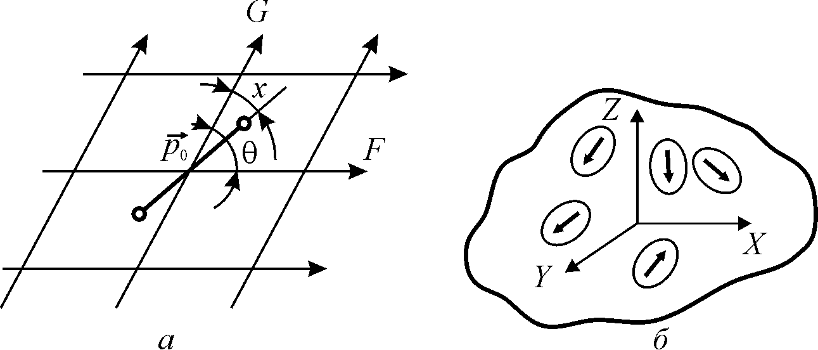

Fig. 2.12. Dipole quasi-elastic polarization: a – dumbbells-like dipole p₀ (bounded in polar lattice by the internal field G) rotates on the angle x under the external field F;
b – averaging method to find polarizability in polycrystalline polar dielectric

In the linear case, it is assumed that the applied field F << G. Calculation of the dipole polarizability α_{d} is based on the fact that the change of the electrical moment of the system under the external electrical field is proportional to the strength of this field: p = α_{d}F. By the analogous method (as for α_{e} and α_{I} in the previous Sections), it is possible to obtain dipole quasi-elastic polarizability α_{d}.
Changing the projection of the electrical dipole moment in the direction of F is due to the dipole rotation angle from the angle θ (at F = 0) to the angle (θ – x) in the case when F > 0:

р = р₀ cos(θ – х) – р₀ cosθ = р₀ (sinθ⋅sinх – 2 cosθ⋅sin² х/2)

Since the field F is small as compared to the field G, then x and angular misalignment is also small, and therefore the value of sin²(х/2) can be neglected in comparison with the sinx. Thus, induced by F change in the dipole moment is p = р₀⋅sinθ⋅sinх. The value of sinx can be found from the condition of the equilibrium – equality torque and returns moments: p₀F⋅sin(θ – х) = p₀G⋅sinθ. This expression in a relatively small effective field (F << G) can be simplified:

sin(θ – х) = sinθ⋅cos х – cosθ⋅sin x => sinθ,

since cos х ≈ 1, a sin x << 1. Thus, it can be obtained: sin x = (F/G) sin θ.
Instead of the internal field strength, it is more convenient to use in the model the energy characteristics of a dipole field G: U₀ = – p₀G cos x ≈ p₀G,
where G = |U₀|/р₀. Next the following expression for the induced dipole moment can be obtained: 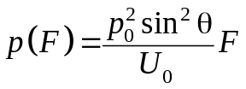. Thus, in this model the polarizability of the quasi-elastic dipole polarization:
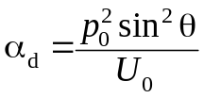. (2.16)
It is interesting to note that this model leads to a dependence of the polarizability on the direction of an externally applied electric field – that is, the angle θ. Therefore, the contribution of this type of polarization can determine the anisotropy of the dielectric constant ε_{ij} which, as it has been shown in Section 2.2, is a second-rank tensor.
It follows from (2.16) that the polarizability α_{d} has maximum at the angles of θ = π/2 and (3/2)π, that is, if F ⊥ G and it is equal to zero when θ = 0 or π when F ⎟⎟ G. If dielectric is a polycrystalline system, then it has a lot of grains-crystallites in which the intracrystalline field G is directed chaotically (Fig. 2.12, b). In this case, it is possible to average the resulting expression (2.16) for the polarizability.
Averaging is performed in the following manner. Obviously, along one of the arbitrarily selected (from the three mutually perpendicular axes) a 1/3 of oriented grains are directed. Let the field F is directed along one of these axes. In this case, the contribution of this one-third grains to the polarizability is zero for the sin θ = 1. On the contrary, a deposition in the polarizability of the remaining 2/3 grains is the maximal, as sin θ = 1. Thus,
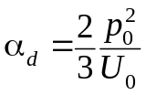.
Quasi-elastic dipole polarization nonlinearity can be calculated using the same method that was used to α_{e} and α_{i} non-linearity, equations (2.13) and (2.15):
α_{d}(F) = α₀ + α₁F + α₂F² + …. ;

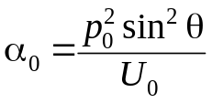; 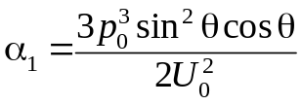
Given model indicates that in the strong electric fields the value of α_{d} may as decreases (if 0 < θ < π/2), so increases (if π/2 < θ < π). When θ = 0 or θ = π/2, the contribution of this polarization mechanism is zero. Naturally, the nonlinearity in these conditions does not occur.

2.6. Thermally activated dipole polarization

Electrons, ions and dipoles, in addition to the elastic polarization, may be involved in the quite different polarization mechanisms, namely, thermal (relaxation) polarization. Thermal motion of particles in the dielectric may have strong influence on the polarization processes in that case, when dipoles, ions or electrons are weakly bounded in the structure of dielectric. Remaining localized in surrounding nano-volumes, these particles under the influence of the thermal motion can make a thermal hopping, moving in atomic dimensions distances.
First model that adequately describes dipole thermal polarization was proposed by P. Debye (1912) to explain high dielectric constant of water and other polar liquid dielectrics. At normal conditions and relatively low frequencies, dielectric constant of water equals ε = 80, while at the optical frequencies ε_{оpt} = n² = 1.77. Such a difference in water’s ε-value at low and very high frequencies is explained by the delay in polar molecules orientation in fast changing electrical field.
When external electrical field is absent (E = 0), the dipoles are oriented randomly, and the electrical moment per unit volume is zero. If electrical field is applied (E > 0), then, in the process of thermal chaotic motion, some part of dipoles becomes oriented along the field, with the result that arises a new equilibrium state – polarized. At that, the thermodynamic equilibrium is settled: due to thermal motions (vibrations, rotations) the dipoles for some time acquire orientation favourable for the field, but the thermal fluctuations prevent the stable orientation of the dipoles in the electric field, so that, an average, only part of dipoles is oriented. The higher the electric field strength (F), the greater is quantity of oriented dipoles per unit volume, and the bigger is thermal dipole polarization. The middle electrical moment calculated per one molecule is proportional to acting local electrical field F (if this field is not too large): <р> = α_{dt}F where α_{dt} is correspondent polarizability.
In the polar gases dipoles rotation occurs freely. In the polar liquids dipole interaction with the surrounding molecules prevents free reorientation process that manifests as a "friction" or viscosity. In the polar crystals the possibility of dipole reorientation is limited: usually dipoles have only a certain number of possible stable orientations, separated by the potential barriers (as in Fig. 2.4, b). In this case, when electrical field is absent, the dipoles are oriented uniformly in all permissible directions, while applied electrical field increases the probability of dipoles orientation in a favourable direction. It is not correct to imagine dipoles reorientation in a form of "mechanical rotation" of dumbbells-like polar molecules – in fact, this orientation (especially in the solid dielectrics) means, for example, the redistribution in the electronic density in the molecule, or the protons hopping between potential minima along the hydrogen bonds, and so on.
The relaxation time of thermally activated polarization depends exponentially on the temperature, fast decreasing during dielectric heating. Under the normal conditions (300 K) for dielectrics which exhibit thermally activated dipole polarization the relaxation time may be 10^{–5}...10^{–9} s. This means that frequency dispersion of thermal polarization takes place in the range of radio frequencies. Therefore, in the dielectrics, in which this polarization mechanism becomes apparent, the dielectric losses at the radio frequencies are significantly increased.
The following is thermal dipole polarization polarizability α_{dt} calculation. It should be noted that in previous consideration of elastic polarization the elementary models of polarization are used: one atom, one pair of ions or one dipole is considered, and the results were generalized to other atoms and molecules, as it is assumed that their polarizability is exactly the same. But in the case of the thermal mechanisms of polarization, it is necessary to consider the statistical models, because only a few dipoles (or electrons, or ions) actually change their orientation (or redistributed in the volume of solid dielectric).
The dipole polarizability α_{dt} primarily depends on relative concentration of dipoles that dynamically change their position (in the same way as electronic thermal polarizability α_{et} depends on the fraction of actually oriented weakly bounded electrons, and ionic α_{it} depends on certain proportion of weakly bounded hopping ions). To maintain a consistent approach to the calculation of the polarizability, which refers to a single dipole, in the case of thermal polarization it is necessary to calculate the actual dipole moment, and divide it by the concentration of dipoles.
In this model, the reorientation of the statistical ensemble of dipoles is considered, in which the probability of a dipole orientation depends on electric field strength, and the average value of oriented dipoles is determined. As a studied model, a spherical volume of dielectric is examined, that contains N dipoles, Fig. 2.13, a). Dielectric sphere is chosen to simplify calculations, but this option does not limit the generality of calculations result. Dipoles have their own electric moment p₀, and they are reoriented independently under the influence of random thermal motion.
Acting on the dipoles local electrical field F changes the random orientation of dipoles into the partially oriented (in accordance with the direction of the applied field), and thus leads to the induced polarization: Р = N<p> = Nα_{dt}F, where <p> is the average moment of a polar molecule, which appears in the current field F.
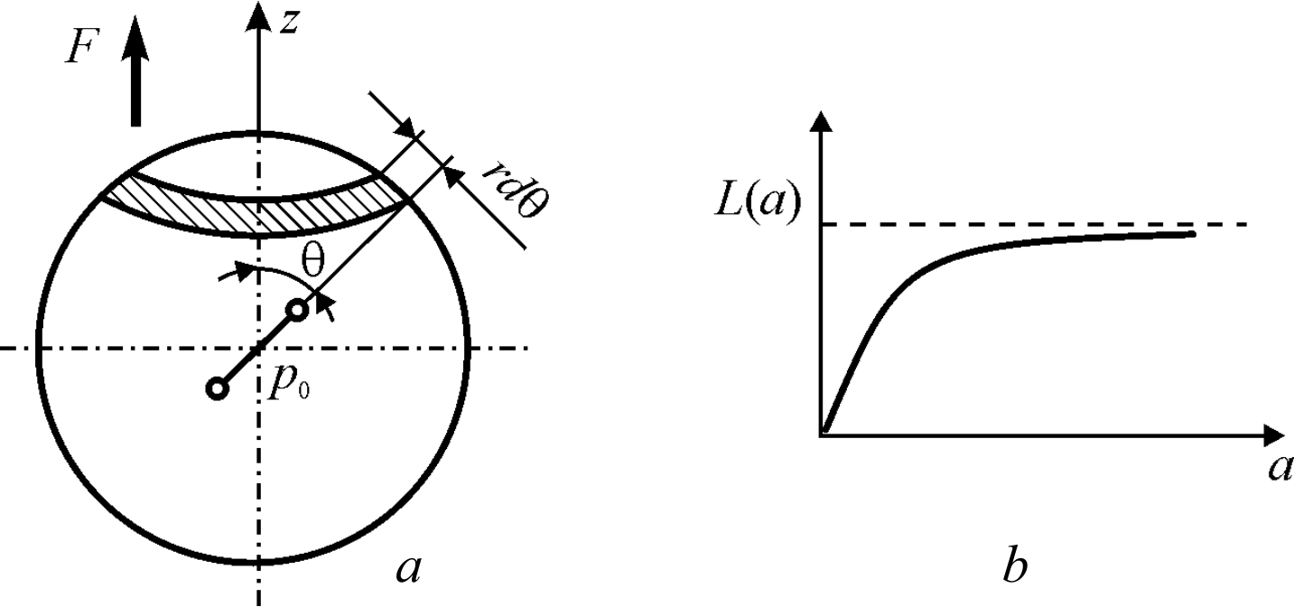

Fig. 2.13. Thermally activated polarization of dipoles (Debye mechanism):
a – dipole moment calculation, b – Langevin’s graph

To find a <p>, one needs to calculate the definite integral in spherical volume of the dielectric shown in Fig. 2.13, a: <р> = Jdp/JdN. Here dN represents the number of dipoles oriented at the angle θ to arbitrary direction (denoted as axis z), i.e., the number of dipoles that being symbolically placed to the centre of sphere were oriented to "a ring", that is, between the angle θ and angle θ + dθ. Electrical moment produced by these dipoles is designated as dp.
To validate the model and the method of calculation, it is necessary first to assume that external electrical field is absent (F = 0), so it is expected, of course, that the polarization P = 0. It is necessary to calculate the average polar moment <p>. The number of dipoles dN is proportional to the area of the ring: 2πR²sinθdθ, where R is a constant (the radius of selected sphere). Therefore, dN = C⋅sinθdθ where C is a constant coefficient. The value of dp is proportional to the cosine of the angle between the z-axis and the direction of dipole orientation, and is proportional to dN: dp = p₀ cosθ dN. The average electrical moment is:
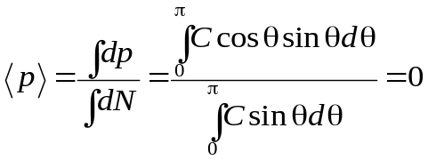
These integrals cover the entire volume of the sphere, that is, the angle θ varies from 0 to π. As it might be expected, in the absence of an external electric field <p> = 0, therefore, the polarized state does not occur (P = 0) because the dipoles are oriented randomly.
Now it should be assumed that the external electric field is applied (F > 0), and it is directed along the axis z. The potential energy of dipole that has own moment p₀ and placed in the local field F, equals to U = –p₀F = –p₀F cosθ. According to the law of Boltzmann distribution, the probability of dipole orientation "in the ring" (angle between θ and (θ + dθ) is defined as:

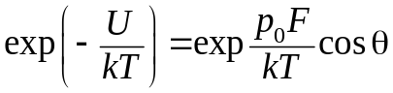.
Accordingly, the number of the dipoles oriented in angle θ changes in the electrical field: dN = C exp[(p₀F/kT) cosθ] sinθ dθ, while the electrical moment produced by these dipoles is dp = C exp [(p₀F/kT) cosθ] p₀ cosθ dN. Next, it is necessary to calculate the ratio <p>/p₀, using obtained for dp and dN expressions, and introducing the notation 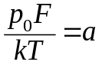and cosθ = х.
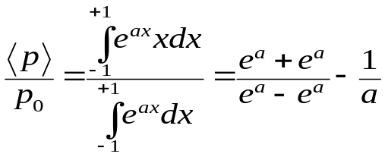, or: 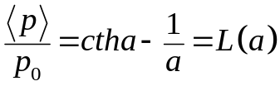 (2.17)
The resulting expression is known as Langevin function L(a), which was first used in the theory of paramagnetic susceptibility. Graph of the Langevin function is shown in Fig. 2.13, b. During these calculations, no assumptions were made about the smallness of the electric field. Therefore, the resulting solution is common – both in weak and in strong fields, that is, for linear and nonlinear cases.
Without assuming that the effective field F is small, the expression (2.17) looks rather complicated. However, the Langevin function can be expanded in series terms of the parameter a:
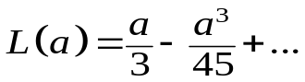 (2.18)
In the case of small values of F, that is, in condition when p₀F << k_{B}T (a << 1), it is possible to use only the first term of the expansion (2.18):

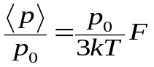; 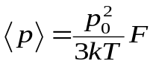.
Thus, the dipole polarizability caused by the thermal motion is given by the formula
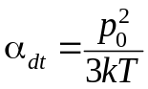. (2.19)
This expression, which was first obtained by P. Debye, plays an important role in the theory of dielectrics. Unlike formulas (2.10), (2.14) and (2.16), that characterize the various types of elastic polarization, the polarizability of thermally activated polarization explicitly includes the temperature. At that, the polarizability decreases with increasing temperature because the chaotic thermal motion prevents the establishment dipoles fixed orientation in the external electric field.

The nonlinearity of the thermal dipole polarization can be obtained on the basis of the expansion (2.18), as usual, in comparison with common series:

α _{дт} (F) = α₀ + α₁F + α₂F² + α₂F³ +….

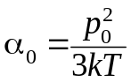; 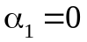; 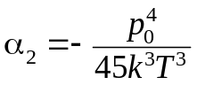; α₃ = 0 …. (2.20)

As can be seen from the above relations, the dielectric permittivity in the dielectrics with thermally activated polarization in the strong electrical fields decreases, because α₂ < 0. In the most dielectrics that are characterized by thermal polarization mechanism the nonlinear effect is experimentally noticeable, but it appears at a field strength which is close to the electric breakdown. This means that inequality p₀F << k_{B}T is satisfactorily to rather strong electrical fields (~ 10⁹ V/m).
Significant nonlinearity in the acceptable fields (10⁴...10⁵ V/m) is peculiar property of paraelectrics that have phase transition of order-disorder type. This effect can be observed in the vicinity of the phase transition to the ferroelectric state. However, in such paraelectrics, the mechanism of polarization only reminds discussed above thermally activated dipole polarization mechanism, since the interaction between dipoles is not taken into account in the Debye model. At the same time, in the ordered dipole-type paraelectrics just this interaction plays a decisive role.

2.7. Thermally activated ionic polarization

This polarization is caused by thermal hopping of loosely coupled ions (usually, impurity ions) in a local area of the crystal lattice. Therefore, such a polarization is the characteristic of solid dielectrics with large concentration of defects in their structure. Such are, for example, glasses, ceramics and glass-ceramics. Really, these dielectrics have high concentration of structural defects: glasses are generally characterized by the only short-range ordering in the arrangement of the ions; ceramics have disordered boundaries between crystallites, while in pyrocerams the regular order in ions arrangement is broken.
However, thermally activated ionic polarization is observed in the single crystals as well – in the vicinity of structural defects. The ions located in interstices, as well as the ionic vacancies (voids in a regular structure) may change the place of their location under the influence of fluctuations of thermal vibrations. During these movements, usually limited by the structural defects (dislocations, for example), the ions overcome potential barriers and linger for a while in new positions, representing the electrical dipoles. However, in the absence of external electrical field, this locally limited movement of charged particles is disorderly, random and can not lead to a macroscopic polarization.
The external electrical field changes the distribution of ions in the crystal lattice defect sites, with the result that electrically induced polarization arises. Setting time of this kind of polarization (relaxation time τ) depends on the temperature, on the peculiarities of crystal structure, and on the type of the defects (or impurities). Typically, at ordinary temperature (about 300 K) the relaxation occurs during τ = l0^{‒4}…10^{–8} s. Polarization delay always leads to an increase in the absorption of the electrical energy. Therefore, such thermal polarization may be the underlying cause of the dielectric losses at the radio frequencies for such commonly used dielectrics as ceramics, glasses and glass ceramics.
To calculate the thermal ionic polarizability α_{it} (with the purpose of relaxation polarization mechanism analysis), it is necessary to use a statistical model. Following is the examination of the thermal ionic polarization of the dielectric.
Thermally activated local hopping is possible only for weakly bounded ions that are localized in the vicinity of structural defects. Suppose that n₀ is the concentration of such ions per unit volume. Value n₀ (10¹⁸…10²⁰ cm^{–3}) is much less than total concentration n of the ions in the dielectric (about 10²³ cm^{–3}).
However, every moment, only a part of these n₀ ions is involved in the mechanism of thermal polarization. At thermal chaotic motion, the loosely ions overcome some average potential barrier U, separating the two (or more) possible locations of these ions. Obviously, the temporal localization of the hopping ions can be maintained only in the case of low temperatures – such that U >> k_{B}T.

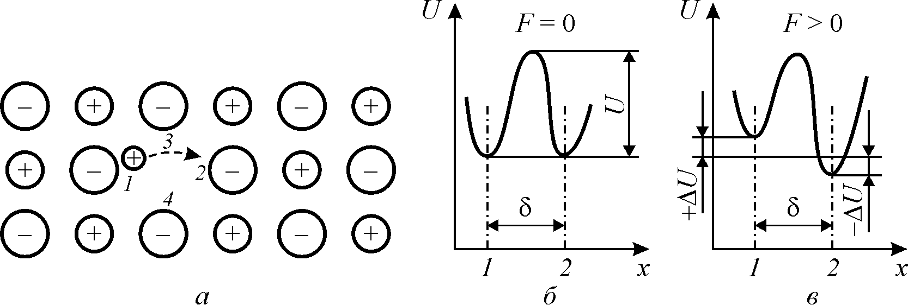
a b c

Fig. 2.14. To the calculation of ionic thermal polarization polarizability: a – small positive impurity-ion is localized nearby one (1) of four possible negative ions, and it has the ability to jump to another nearby ion (2); b – in the absence of external field the positions 1 and 2 are equally likely, b – external field stimulates jumps 1→ 2

Along any particular direction, elected in a dielectric, for example, along the x axis (Fig. 2.14), in average the only n₀/3 of weakly bounded ions moves. The middle distance, separating the probable position of these ions localization, has the order of lattice constant (δ ≈ 10^{–9} m). Traditionally δ is called as the length of the "free path”.
In the Fig. 2.14 the equiprobable positions of ions in potential minima are denoted as 1 and 2. The probability for moveable ion to acquire required energy is ехр(–U/k_{B}T), that should be greater or equal to the height of barrier U (probability of ion hopping between equilibrium position of potential wells 1 and 2 at a temperature T). In this case, the ion overcomes the potential barrier and jumps, for example, from the position 1 to the position 2 (or vice versa). If the frequency of ions thermal vibrations in the lattice (Debye frequency) is the ν Hz, from position 1 to position 2 (and meet), per one second, jumps over the next number of ions:
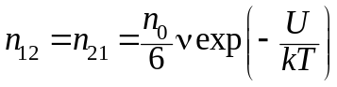. (2.21)
It is obvious that in the case of such counter-diffusion the electrical polarization cannot appear. If the dielectric is exposed to the electrical field F directed along the selected axis x, the probability of weakly bounded ions transition from the position 1 to the position 2 should increase, Fig. 2.14, b, while the probability of colliding transitions should decrease. The fact that the height of the potential barrier that ions must overcome, in the first case, is reduced to the value ΔU while the in the second case is increased by the same ΔU (which is a resulting energy obtained by ion as it moves in an electrical field F on the distance δ/2, that is ΔU = qFδ/2).
Thus, an electrical field disturbs a uniform symmetry in the distribution of the defect ions. After some time after the electric field is applied, it turns out that п₂ > п₁:
п₁ = п₀/6 – Δп, and п₂ = п₀/6 + Δп.
Such electro-stimulated diffusion of ions leads to the polarization. Since Δп represents the excess concentration of ions turned to 2-position, it is clear that electrically induced moment per unit volume of dielectric (polarization) is Р = Δпqδ.
In this model of thermally activated polarization, from the total number of weakly bounded ions (n₀), only some of them (Δп) are actually jumped over the potential barrier. To determine a part of any single impurity ion in thermally induces polarization P = Δпqδ, it is necessary to calculate the average elementary polarizability α_{it} when P = п₀α_{it}F. Thus, the polarizability for thermal ionic polarization:
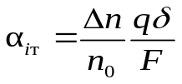. (2.22)
Further calculations are reduced to finding the value Δп, which depends on electrical field intensity. It is possible also to find the time required for thermal ionic polarization settling; so during the solution of this problem it is necessary to take into account the dependence Δп on time. It is obvious that 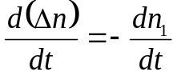. Thus, it is necessary to consider the dynamics of changes in the concentration of excess ions in the 1-position after the field F is applied. In the transition from position 1 to position 2, the ions overcome the potential barrier 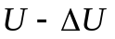, while at the opposing jumping they overcome a barrier 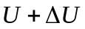:

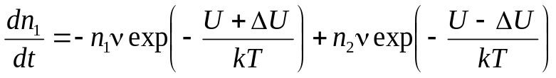.

After substituting values n₁ and n₂:
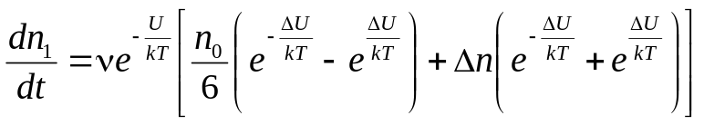. (2.23)
In the weak electrical fields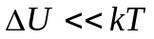, so that it is possible to make substitution
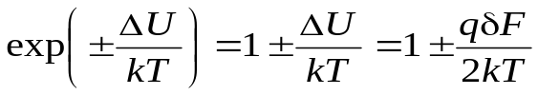.
In this case, the equation (2.23) can be simplified:

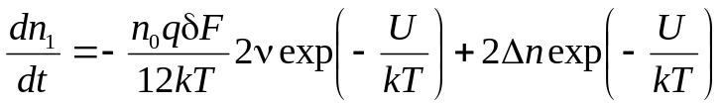.
Further, it is advisable to introduce an important notation:

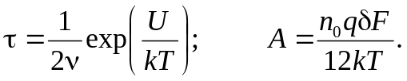 (2.24)
Parameter τ has dimension of a time, and it is the relaxation time, which is determined by temperature, by frequency of ions thermal vibrations ν and by value of potential barrier U. It is seen that τ is exponentially dependent on temperature (increases very rapidly with decreasing temperature).
After substituting the new notation, equation (2.24) takes the form:

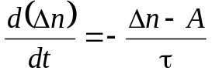. (2.25)
The solution of this differential equation as follows

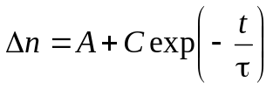.
The integration constant C is determined from the initial conditions: when t = 0, the Δn = 0. Substituting the values of A, the sought Δn is:
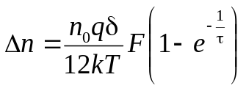 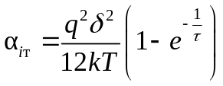. (2.26)
If the electrical field is valid for quite a long time (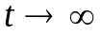), the thermal ionic polarization can be established as
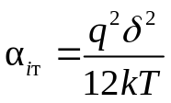. (2.27)
As it can be seen, the polarizability of the ionic thermal polarization depends on the temperature (decreasing with increasing temperature) because the intensity of the thermal vibrations prevents the ordering of the impurity ions distribution in the potential traps.

Non-linearity of ionic thermal polarization mechanism. In the sufficiently strong electric fields the nonlinear properties of any polarization mechanism should be observed. Ionic thermally activated polarization, in this sense, is no exception. The non-linearity should arise in cases when strong electrical field causes the ions flip-over through the potential barrier (in the weak fields ions jumps are carried out by the fluctuations of the thermal vibrations, and the electric field only changes their probability).
Taking into account the non-linearity might be made in traditional way (as in the case of elastic electron polarization), by simplification of the expression (2.23) using the expansion of exp(±ΔU/kT) in Taylor series (in addition to the first term of this series it needs to consider next few terms).
However, integration of the equation (2.23) can be performed in a general way, without series expansion. This allows take into account the non-linearity. Indeed, the expression in parentheses (2.23) may be recorded as hyperbolic sine and cosine. Representation of the equation (2.23) by this way:

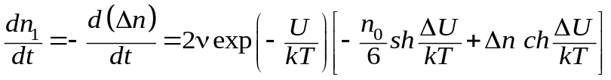.

By introducing notation 2ν exp(–U/kT) = 1/τ₀, the above expression may be converted to the following equation:

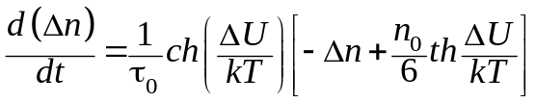.

The solution of this equation for Δn has the form:
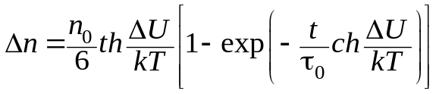.
As a result, it is possible to obtain an expression for the nonlinear susceptibility:
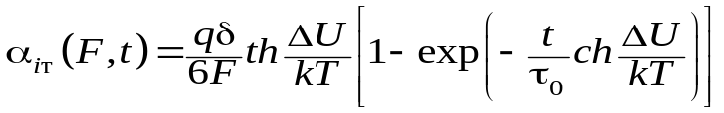.
In the case where the polarization is established, t → ∞,
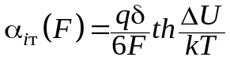
Turning to the traditional method of accounting nonlinearity (series expansion,
α_{iт}(F) = α₀ + α₁ F + α₂ F² + α₃F³ +. . . ), the hyperbolic tangent series for parameter ΔU/kT is: 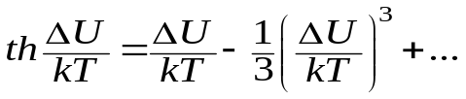
Thus, for the evaluation of thermal nonlinearity ionic polarization can be obtained: 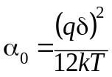; 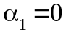; 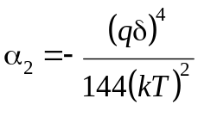; 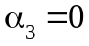.
It means that in a strong electrical field the so-called saturation of polarization is observed, and thus, the dielectric constant decreases.
The relaxation time is also dependent on the electrical field:
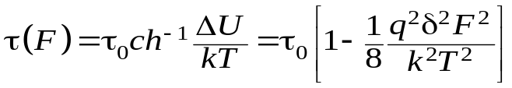. (2.28)
As is follows from this analysis, in the strong electrical field (when a forced carry-over of impurity ions over the barrier takes place), the thermally induced (hopping) polarization becomes quicker. Thus, the settling time of polarization as well as the polarizability decreases in a strong field.
With rare exceptions, the non-linearity of thermal ionic polarization is observed only in very strong fields that are comparable with the breakdown electrical field. However, given above consideration of the nonlinearity of the ionic polarization mechanism has some theoretical interest. If crystal has increased permittivity, it is possible to obtain correlation between impurity ion orientations and, finally, to create the artificial ferroelectric (the example is solid solution (K_{1‒x}Li_{x}TaO₃) where x = 0.1…0.2 is Li concentration).

2.8. Thermally activated electronic polarization

This mechanism of polarization is possible only in solid dielectrics. Suppose that in the neighbourhood of a certain type of structural defects in the dielectric there are weakly bounded electrons (or electronic holes), which may be in two or more equivalent positions – “traps”, separated by a potential barrier. Usually these electrons are captured by the crystal defects or impurity ions. These centres represent the places of irregularly distributed of electric charge in the crystal lattice.
Captured by vacancies electrons (holes) can lead to thermal polarization only in the case when the ground state of the electrons is degenerate, and the combination of degenerate wave functions can create a dipole moments. In the absence of electrical field, under the influence of thermal fluctuations, the electron or hole successively passes from one place of location to another. Obviously, that these chaotic movement of charges does not lead to the polarization if the external electrical field is absent. Application of this field stimulates the "unipolarity" of electronic transitions, and leads to the induced by an external field electrical moment, i.e., increases the polarization.

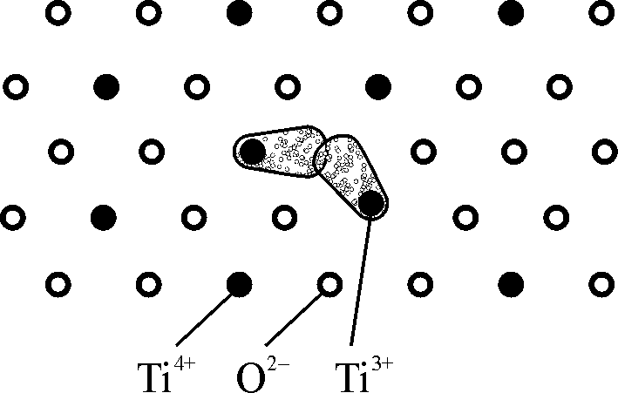
Fig. 2.15. Electronic thermal polarization in rutile: planar lattice model of titanium dioxide with oxygen anion vacancy

The relaxation time for the mechanism of thermally activated electronic polarization is relatively long: 10^{–2}...10^{–7} s. This polarization is essential in technically important dielectrics, such as rutile (TiO₂), perovskite (CaTiO₃) and similar complex oxides of titanium, zirconium, niobium, tantalum, lead, cerium and bismuth. In these substances, especially in their polycrystalline state, a high concentration of defects in the crystal structure is observed. During the synthesis of ceramics from the mixture of oxides (or while crystal growth) a very high temperature is used, and, therefore, it is very likely the appearance of oxygen defects – anion vacancies. Electrical compensation of these defects occurs by lowering the valence of the cations located near an anion vacancy. Thus, the appropriate conditions of electronic exchange between the neighbouring cations appear, that leads to the polarization.
Figure 2.15 shows one of possible demonstration of electronic thermal polarization in the rutile. In a selected section of the crystal TiO₂, there are three titanium ions as the neighbours to anion vacancy (in the bulk crystal there are five of such neighbours). Because of the charge compensation, the oxygen ion lack in the lattice (vacancy) is surrounded by two adjacent trivalent titanium ions: they contain in their outer shell the one "weakly bounded" electron. The model assumes that these two electrons can overcome some of the potential barrier and jump (redistributed) between five titanium ions, adjacent to the oxygen vacancies.
In the absence of an electrical field, these transitions of electrons occur under the influence of chaotic thermal lattice vibrations, therefore, these polar centres are randomly oriented, and do not lead to the total polarization. After electrical field is applied the transitions of electrons around anionic vacancies becomes asymmetric, that leads to the induced polarization. By this way it is possible to describe the electronic thermal polarization of rutile.
It should be noted that the concentration of defects in the crystal can not be very large; nevertheless, the contribution of this polarization mechanism to dielectric constant can be big enough due to a very high polarizability of greatly enhanced electronic orbits located near the defects. The wave functions of these "semi-free" electrons "smeared" in a large enough volume in the vicinity of the vacancy. To estimate the reason of this high polarizability, it be should noted that in the case of electronic elastic polarization the value of polyrizability α_{e} is proportional to the cube of electronic orbit radius.
The model presented in Fig. 2.15 is something equivalent to the mechanism described above for the ionic thermal polarization. It can be argued that the results of the statistical model for ionic polarization can be applied to the mechanism of electronic thermal (relaxation) polarization. Then the polarizability of electronic thermal polarization is
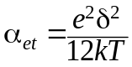 (2.29)
where δ is the distance between equilibrium states, and e is electron charge. In ceramics rutile (TiO₂) at ambient temperature the dielectric constant at frequency 10 GHz equals ε_{mic} ≈ 100.
At low frequency (about 10 kHz), depending on the concentration of anionic defects, due to the electronic thermal relaxation the low frequency permittivity may rise to ε ≈ 110...2000.
In the metals and semiconductors, electrons and holes in the crystals should be considered as quasi-particles – specific excited states of the crystal. However, in the dielectrics at high enough temperatures to describe the motion of electrons (holes) in the crystals the quantum-mechanical effects might be neglected. In the dielectrics, due to the electron-phonon interaction, the effective mass of an electron in a crystal can be much larger than the mass of a free electron.
Typically, a large value of electron’s effective mass indicates that it is in the polaron state. As a rule, this state of electrons and holes occurs in dielectrics with a high elastic ionic polarizability, in which the difference ε_{iоn} – ε_{оpt} is significant. Discussed above rutile just belongs to these dielectrics, as well as the dielectrics which have perovskite structure. It should be noted, however, that the precise calculations of thermally activated electronic polarization in such dielectrics are rather complicated.
More convenient model for theoretical study and comparison with experiment are ionic crystals of simple structure: alkali-halide crystals or crystals of semiconductors such as ZnS. In the first case, the appearance of electronic relaxation polarization is associated with the excitation of colour centres – the so-called F-centres. They are structural defects that arise as a result of the localization of electrons near the vacant anion sites in a simple cubic crystal lattice. However, in the alkali halide crystals with a normal (low) concentration of F-centers it is difficult to obtain reliable experimental data on the contribution of the electronic thermal polarization due to effect smallness.
It should be noted that the colour centres, such as F-centres, occur in other crystals, such as quartz (model presented above for rutile in Fig. 2.15 resembles F-centre). Colour centres are usually activated by hard radiation. It has been experimentally shown that in the irradiated crystals of “smoky” quartz at low temperatures the relaxation polarization is observed due to defects in the vicinity of the captured electrons or holes.
In the latter case, crystals of zinc sulphide or cadmium sulphide, the electronic polarization occurs after photo-activation of crystal by ultraviolet radiation. At that, the observed dielectric spectra are specific for the relaxation (thermal) mechanism of polarization with temperature maximum of dielectric losses. In these experiments, it was found that the relaxation time depends on the temperature according to the relation τ = τ₀ ехр(U/k_{B}T). However, the thermally activated electronic polarization in ZnS and CdS crystals with impurities was noted only after or during illumination of these crystals. Therefore, the observed effect of dielectric constant increase is called as a photo-dielectric effect.
The accurate calculation of the polarizability for electronic thermal polarization can be made only on the basis of quantum-mechanical model. This model, proposed by H. Frohlich, supposes that the certain conditions are necessary for electrons (holes), trapped by crystal defects. First of all, the ground state of relaxing electrons should be degenerate. Furthermore, in an energy band of the order of k_{B}T, above the ground state, at least two energy levels must exist. This may occur, for example, in the case where the electron (that compensates anionic position) has the ability to localize at several adjacent positive ions (situation similar to Fig. 2.15).
The same situation may occur when the cation vacancy is compensated by the hole (absence of an electron) which can be located nearby surrounding anions. In these cases, the possibility of splitting of the ground state is obvious, at that the magnitude of the splitting is assigned by the exchange integral of electrons transfer between the neighbouring cations (or integral of holes transition between the anions). It is also important that the combination of the wave functions of the degenerate levels led to the appearance of the dipole moment. Therefore, some of these levels must be even, and the other – odd. The last condition depends on the symmetry of the wave functions in different structures. These conditions are difficult to meet in the so-called "hard" (weakly polarizable) crystal lattice. In the opposite case, when the defective electron causes a deformation of the crystal lattice and thus provides degeneration (non-equivalence) levels, it is in the polaron state. Under these conditions, the stronger the interaction of electron with lattice distortion, the greater is the probability of electron polarization.
Thus, the electronic polarization caused by the thermal motion is related to quite a wide range of processes occurring in solid dielectrics: photo-dielectric effect in the crystals of wide-band luminescent semiconductor, dielectric relaxation in the ionic crystals due to the presence of colour centres, dielectric relaxation of electrons trapped in the donor centres of oxide semiconductors, and, finally, a significant increase in low-frequency permittivity in the polycrystalline materials of perovskite type and rutile.

2.9. Clausius-Mosotti-Lorentz equation

An important problem in the physics of dielectrics is the calculation of macroscopic parameter – permittivity ε – from the derived above expressions for polarizability of various mechanisms (α_{e}, α_{i}, α_{d}, α_{et}, α_{іt}, α_{dt}), which are expressed through molecular constants of dielectric. The ratio obtained in Section 2.1, in principle, allows calculate dielectric constant, when total dielectric polarization P is known:
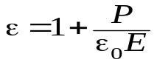. (2.30)
Obviously, when dielectric shows several (k) non-interacting polarization mechanisms, the electrical moment per unit volume of the dielectric can be found from the following expression:

P = (∑ n_{k}α_{k}) F, (2.31)

where F is the acting on the particles electrical field, α_{k} is the polarizability of the k-th mechanism, and n_{k} is particles concentration for k-th polarization mechanism. Of the above models of elementary mechanisms of elastic and thermal polarization k = 1, 2, ..., 6.

Local (acting) electrical field in dielectric. It would seem that the expression (2.30) and (2.31) can completely solve the problem of calculating the dielectric constant through known molecular constants of dielectric – by the polarizabilities. However, in order to use this expression, it is necessary to find the relationship between the average macroscopic field E and the acting (local) field F. This section deals primarily with this very important problem in the theory of dielectrics. Only in the case of gases, which molecules are spaced from each other at a comparatively large distance, it can be assumed that
F ≈ Е, (2.32)
at that the field Е = (D – Р)/ε₀ characterizes the field of external electric charges (D), slowed by the "depolarizing" charges that appear on the surface of the dielectric (near the electrodes) due to the polarization (P). In the liquid and solid dielectrics the local (acting) field is significantly different from the field E; generally
F ≈ Е + Г, (2.33)
where Г is the resulting field, taking into account the impact on all other polarized particles in dielectric.
The general problem of finding the field F without specific structural features of given dielectric is very complex. G. Lorentz proposed an important simplification of this problem, in which a local field E_{Lor} was found for dielectrics that have no polar molecules in its structure. Under this condition, it appears that
F = Е_{Lor} = Е + Е₁, (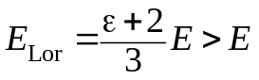). (2.34)
The field Е₁ = Р/3ε₀ is conditioned by the action all remote polarized particles on a given particle. Lorentz proved that in the non-polar dielectrics the influence of closely spaced particles cancel each other, and can be ignored.
Using equation (2.34), which is a good approximation for non-polar dielectrics, it is possible to obtain a total estimated relation between the dielectric constant and polarizability. This ratio, usually called by Clausius-Mosotti, was first established while they studied optical properties of dielectrics (i.e., only for the special case of quasi-elastic electronic polarization), and then was generalized by Lorentz for other mechanisms of polarization. However, in the case of polar (liquid or solid) dielectrics, Clausius-Mosotti-Lorentz formula cannot be applied – this is the so-called "polarization catastrophe."
Since the Lorentz approximation was very successful solution of the problem, the relation (2.34) is possible to generalize to polar dielectrics. In this case, in weak electrical fields (i.e., for linear dielectric) the following expression can be written:

F = Е + Е₁ + Е₂. (2.35)

Field E₁, as in the equation (2.34), is the Lorentz correction, while the field E₂ takes into account the impact on the particles located close to concerned one (as already noted, for the non-polar dielectrics it can be considered Е₂ = 0). The fields in the expression (2.35) are shown in Fig. 2.16, and, respectively:

Е = (D – P)/ε₀; Е₁ = P/3ε₀; Е + Е₁ = Е (ε + 2)/3.

The field E₂, in the general case, is a projection of the internal field B on the direction of the external field E, Fig. 2.16, b; it takes into account the effect of polarized molecules adjacent to the considered particle. The calculations of the local field for polar dielectrics were conducted by many researchers. The solutions, obtained in some cases, are in good coincidence with the experimental results for the individual polar dielectrics, but are not universal.

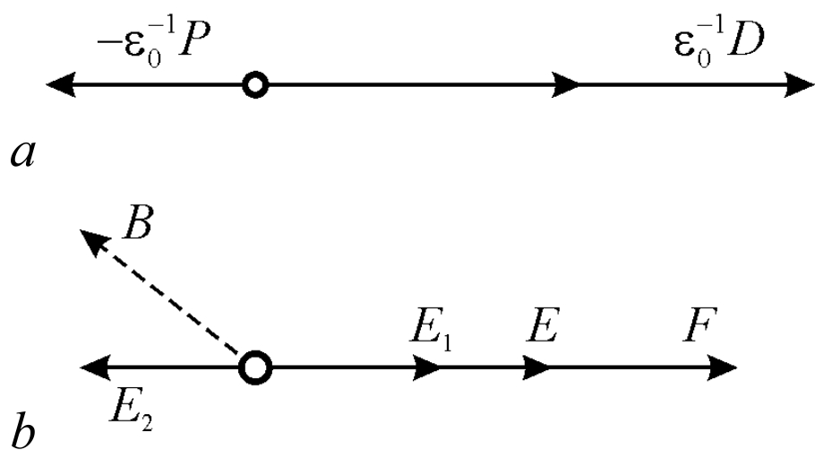
Fig. 2.16. Electrical fields in the dielectric: a – average macroscopic field Е = = D/ε₀ – P/ε₀,
b – local field acting on each particle, F = Е + Е₁ + Е₂

The most important solutions of this problem were obtained in the studies of L. Onsager, J. Kirkwood and G. Frohlich. The calculation of the local fields in the low-symmetry and dipole-structured dielectrics is considered one of the most difficult problems in the theory of dielectrics.
Quite simple and at the same time very important example of the application of the theory to properties of dielectrics is to describe polarization of ionic crystals. Next, in Section 3.3, a model based on the dynamics of the crystal lattice is discussed. Designed by M. Born, dynamic model allows not only correctly explain the infrared polarization and electromagnetic infrared absorption of the ionic crystals, but also to establish a number of important relationships, which include the ratio of Liddeyn-Sachse-Teller to obtain an equation that relates the dielectric constant, the optical refractive index and the frequency of the transverse and longitudinal optical phonons. Born dynamic theory explains specific properties of ionic crystals with a very high dielectric constant.

Dielectric constant of gas. In gases, the elastic electronic polarization α_{e} and thermally activated dipole polarization α_{dt} should be considered. Since the interaction of the molecules in gases can be ignored, it is natural to assume that the local field (acting on the molecule) differs only a little from the average macroscopic field (F ≈ Е), and the static dielectric constant is not much greater than one.
Using the above relations and taking into account the above assumption, it the following formula can be derived for dielectric constant of gas:
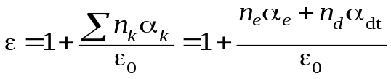 (2.36)

α_{е} = 4πε₀r³; α_{dt} = p₀²/3kT.
In the non-polar gases, dielectric constant is almost equal to optical refractive index:
ε_{el} = ε_{opt} = n² = 1 + n_{е}α_{е}/ε₀, α_{е} = 4πε₀r³.

Assuming α_{е} ≈ r_{е}³ ≈ 10^{–30} m³, and taking into account that, under normal conditions, the concentration of molecules in the gas is n_{е} = 2.7⋅10²⁵ m^{–3}, it is possible to estimate the order of magnitude of permittivity: ε_{el} = 1.0004. In fact, this value is equal to 1.00055 for oxygen, 1.00027 for hydrogen, 1.00058 for nitrogen, but quite low for helium: ε_{el Не} = 1.00007.
This is due to the nuclear (not molecular) structure of helium. Calculated ε_{el} in the non-polar gases is completely consistent with the results of optical measurements of the refractive index.
In the polar gases containing dipole molecules, such as steam H₂O, vapours of HC1, CO, NH₃ and others, it is possible to divide the dielectric contributions of electronic and dipole polarization, by comparing the optical refractive index n with the value of the gas permittivity ε_{lf} measured at low frequency:

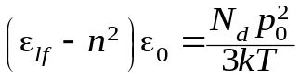, (2.37)

where p₀ is dipole moment and N_{d} is concentration of polar molecules. This measurement technique and the relation (2.37) is used for the experimental determination of the dipole moments of different molecules. Data on the value of the dipole moment of complex organic molecules contribute to deciphering of molecular structure and to construction of correct models of these molecules.
Thus, the theory of dielectric polarization of gases is quite perfect. The calculation of the dielectric constant using known molecular parameters has no fundamental difficulties, and the data obtained are in good agreement with measurements.

Lorentz model for local field calculation. A simplified method for homogeneous non-polar dielectrics’ local field calculation is considered below. For each polarized particle (ion, atom, molecule), dielectric is as a continuous medium that is characterized by certain macroscopic parameters. In fact, each particle is surrounded by the adjacent particles and is influenced by the microscopic fields of their neighbours. In gases, due to the large distances between the molecules, the influence of these microscopic molecular fields can be neglected. But in the condensed phases (liquid and solid dielectrics), as well as in the highly compressed gases, such assumption is unacceptable.
For microscopic field calculation, Lorentz has introduced a conception of physically infinitesimal volume that gathers round this molecule and constitutes a sphere of radius r. The spherical shape is not critical, and it is selected solely for ease of calculation. Lorentz sphere radius is such that it would be possible to take into account the influence of nearest neighbour polarized particles which are within the sphere. It is assumed that influence of molecules, located in the outside area, can be taken into account as the influence of the polarized continuous medium. Accordingly, the sum of fields is introduced as

F = Е + Е₁ + Е_{2.}

Here E is the average macroscopic electrical field, the field E₁ describes the influence of distant molecules fields (located outside the Lorentz sphere), and the field E₂ characterizes the microscopic field of closest to the given molecule environment. Macroscopic field E is generated by the electric charges that are located outside of a dielectric and by the dielectric polarization P, and can be determined from equation (2.30): 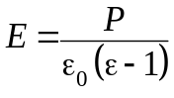.
To calculate the Lorentz correction (the field of polarized sphere) it is assumed that all the molecules inside the Lorentz sphere are removed. Then the problem reduces to the calculation of the electrical field created inside polarized dielectric sphere. It should be assumed the presence of associated electric charge on the surface of a sphere – this representation is equivalent to polarization of empty sphere in dielectric, Fig. 2.17.
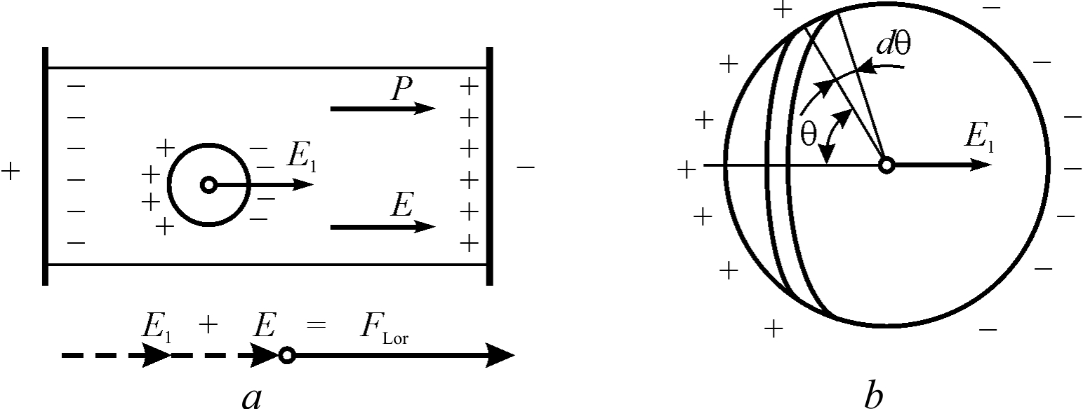
Fig. 2.17. Approximation to calculate the Lorentz local field:
a – allocation of Lorentz sphere in dielectric; b – calculation of polarized sphere field

Electrical charge located on the elementary surface dS is denoted by dq. For ease of integration, the elementary surface is selected as a ring on the sphere, located at an angle to the direction θ external electric field. Elementary charge dq creates field in the centre of the sphere

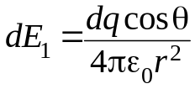.
The value of the elementary charge located in the considered ring is proportional to the charge density and to the ring surface: dq = ρ_{s}dS. The density of electric charge depends not only on dielectric polarization value, but also an angle which elementary area (shown in Fig. 2.17, b) forms with the direction of macroscopic polarization, i.e., ρ_{s} = Р cosθ. The ring surface is determined by the parameters chosen in this task: dS = 2πr²sinθ⋅dθ. These expression should be substituted into the formula for dE₁, and after integration over the entire surface of a sphere, it can be obtained:

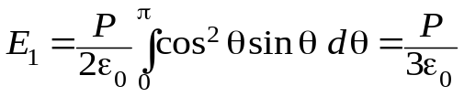.

Thus, the polarized dielectric medium, which is beyond the scope of the Lorentz sphere, creates in the centre of the sphere electrical field Е₁ = Р/3ε₀. In the Lorentz approximation, the local field is determined by the sum F = Е + Е₁:

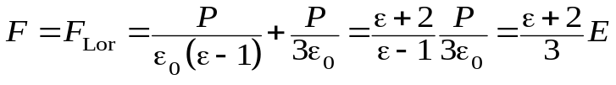. (2.38)

It follows that Lorentz field exceeds the average macroscopic field in (ε + 2)/3 times. Obviously, the dense polarized media in liquid or solid dielectrics increases current (local) field acting on the particle. However, in gases ε = 1 and F_{Lor} = Е, so Lorentz model confirmes previous calculations made for gases.
Now it is necessary to evaluate E₂ that is the field of polarized particles located inside spherical cavity. In the case that dielectric contains polar molecules (so-called "hard" dipoles) the concerned molecule is affected by strong internal electrical fields induced by these dipoles, and these influence depends on random thermal motion in polar dielectric. In these cases, it is impossible to ignore the field E₂. However, in the non-polar dielectrics, these local field are created only by the induced external electrical field dipoles ("soft" dipoles), and in the most cases the effects of their fields is compensated.
The Lorentz approximation just meant a case of total compensation of the local field caused by the particles inside the sphere. This assumption, as already noted, is true in many dielectrics. The point is that for each of polarized particles, located inside the cavity, it is always possible to find a particle which action compensates the action of the first particle.
Such compensation is almost always possible in the case of a disordered arrangement of atoms (or molecules) in the dielectric, i.e., in the case of non-polar liquids. Note that during chaotic thermal molecular motions a violations (fluctuations) are possible, but in average yet it is possible to put the field E₂ = 0.
A similar result can be obtained for solid isotropic dielectrics, for example, for many non-polar solid-amorphous dielectrics, in which E₂ = 0 can also be considered. In the crystals, the compensation of inside-sphere local field is possible only for highly-symmetric (simple) structures, and this is confirmed by the calculations.
Lorentz approximation provides a relatively simple expression for the calculation of the dielectric constant of the non-polar and highly-symmetric dielectrics based on known molecular parameters. Using the general expression (2.2), which relates the polarization and dielectric constant, and the formula (2.38), in which the effective field is expressed through the polarization, it is possible to obtain Clausius-Mosotti-Lorentz equation:

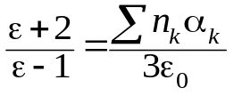 (2.39)
The equation (2.36) which is used to calculate the dielectric constant of gases (in which the value of ε differs a little from unity) can be obtained from the equation (2.39) as a special case, if one put (ε + 2) = 3.
Clausius-Mosotti-Lorentz formula can be used, primarily, for the calculation of the permittivity of non-polar and polar gases, not only sparse but compressed as well. In this case, take into account two possible mechanisms of polarization: quasi-elastic electronic and thermally activated dipole polarizations:
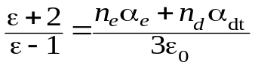.

With some approximation, equation (2.29) describes dielectric properties of non-polar and weakly polar liquids and solid dielectrics, which are characterized mainly by the electronic polarization:
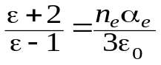. (2.40)
Such dielectrics have ε value of 1.8...2.5 that is close to squared optical refractive index. As examples of this type liquid dielectrics may serve benzene, carbon tetrachloride, transformer oil and other non-polar dielectrics. Non-polar solid dielectrics (in which ε ≈ n²) include paraffin, polystyrene, Teflon, rubber, and the like. The dependence of the dielectric constant on the temperature of such dielectrics is negligible; the nonlinearity of these dielectrics is also practically invisible.
An important for applications temperature parameter ТCε = ε^{–1}dε/dT can be determined from the equation (2.40) under the assumption that polarizability α_{е} is independent on temperature. By differentiating both sides of this equation with respect to temperature, and after some transformations, it can be obtained
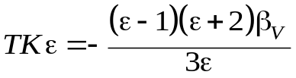, (2.41)

where β_{V} is volumetric coefficient of thermal expansion. Indeed, in these dielectrics temperature dependence of ε is due almost entirely to the thermal expansion. The resulting ratio indicates that parameter ТCε is negative for the non-polar liquid and solid dielectrics, as in all of these substances β_{V} > 0.
Clausius-Mosotti-Lorentz equation can also be applied to describe the dielectric properties of liquid solutions polar liquid in the non-polar one. In this case, however, such solutions should not be concentrated in order to polar molecules were far removed from each other. Using equation (2.39) for permittivity calculations, it should be noted that n₀ is the concentration of dissolved polar molecules having their own dipole moment p₀. Such solutions, due to polar molecules, is characterized by the Debye polarization mechanism, so the temperature coefficient of dielectric constant can be positive.
Thermally activated ionic and electronic polarizations, unlike Debye dipole orientation mechanism, is possible mainly in solid dielectrics having the imperfect structure. As a rule, structural defects are located sufficiently far from each other, so at high temperatures their interaction might be neglected. Therefore, for the non-polar solid dielectrics that have simple structure, these mechanisms contribution to the dielectric constant can also be taken into account by using the equation (2.39). In this case, however, the effect of surroundings polarization on the electrical dipole moment does not considered.
Thus, the Clausius-Mosotti-Lorentz equation can be considered as a basic relation that allows calculate the dielectric constant from known molecular constants for most dielectrics.

2.10. Migratory polarization

Lorentz model and based on it dielectric constant calculation is valid only in the case of microscopic mechanisms of polarization. In the inhomogeneous dielectrics, besides already discussed thermal and elastic polarization mechanisms, the electrical moment per unit volume might originate from the macroscopic mechanisms of charge accumulation in the area of inhomogeneities. In some cases, this polarization plays a significant role, as for need specific changes in dielectric’s properties so for electrical reliability control.
Migratory (space-charge) polarization is an additional mechanism of polarization, which is typical in solids with inhomogeneous structure or in the presence of macroscopic defects. This polarization becomes apparent only at low frequencies, and causes a considerable dissipation of electrical power (losses). The cause of this polarization might be layers of different conductivity, or the presence of metallic of semiconductors particles in the technical dielectrics, and so on.
Migratory polarization mechanism can arise, for example, as follows: when inhomogeneous materials is placed into electrical field, free electrons and ions of conductive and semiconductive inclusions move within each inclusion, which becomes similar to polarized region. In the same way, in the border layers and near-electrode layers, the slowly moving ions may accumulate, which also has the effect of migratory polarization. To the migratory polarization, the ionic relaxation in the case when the movement of weakly bounded ions occurs at distances greater than the crystal lattice period may be included.
Since migratory polarization is a macroscopic mechanism, its modelling and analysis is advantageously carried out using equivalent electrical circuits. The simplest equivalent circuit of space-charge polarization modelling in the inhomogeneous dielectric is shown in Fig. 2.18.
This polarization is possible only at low frequencies. Therefore, the relatively rapid processes of thermal and elastic polarization are modelled on the equivalent circuit by capacitor С(∞) referring to a sufficiently high frequency (ω → ∞), at which the slow process of polarization is no longer appear. In addition, the resistor R takes into account the electrical conductivity of the dielectric, while migratory polarization itself is represented in the diagram (Fig. 2.18, a) by serial chain r – C_{a}.

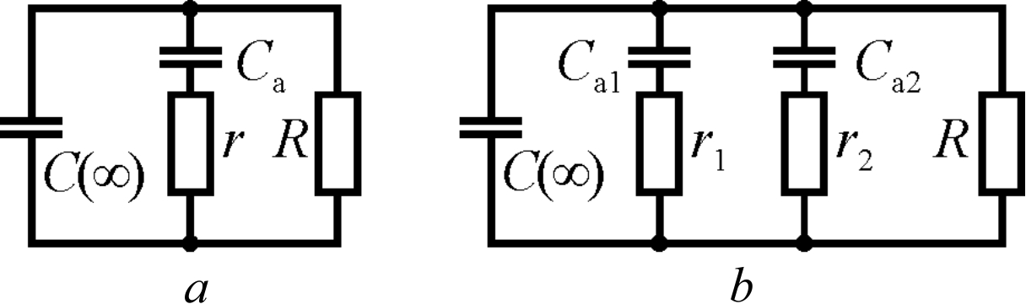

Fig. 2.18. Equivalent circuits of inhomogeneous dielectric space-charge (migratory) polarization in the case of one (a) and two (b) relaxation times

To investigate the nature of migratory polarization, it is desirable to move from the equivalent circuit parameters С(∞), С_{а}, r and R to the parameters of the dielectric: ε and tanδ, that allows, firstly, to describe the main contribution of migratory polarization into the effective permittivity as well as to describe frequency dependence, temperature dependence and field intensity dependence.
If electrical conductivity would be neglected (R → ∞) the analysis of the equivalent circuit of the migratory polarization will be simplified. The transition process for the part of the circuit r – C_{а} (voltage U_{a} in the capacitor C_{a} decreases with time in the event of closing of this chain) is described by the equation
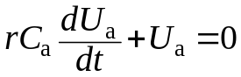,
which solution is expression U_{a} = U₀ exp (–t/τ_{a}) where τ_{a} = rC_{а}. The complex conductivity (admittance) for the simplified (R → ∞) scheme (shown in Fig. 2.18, a) equals to:
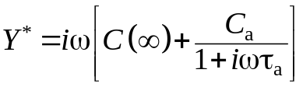
Since the scheme has both active and reactive conductivity, the total conductivity is a complex value. Sharing its real and imaginary parts, it is possible to have:
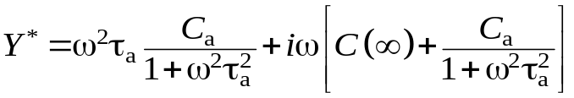. (2.42)
The equation (2.42) should be compared with known expression for capacitor conductivity: 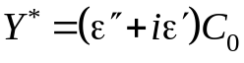, where C₀ the geometric factor binding value to the size of the capacitor. After this comparison, next formulas for migration polarization effective parameters can be obtained:

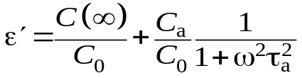 , 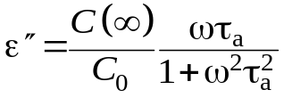. (2.43)

Thus, it is possible to define a low frequency dielectric constant as 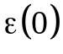 (before frequency dispersion, when frequency 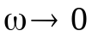), and high frequency dielectric constant 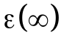 (after frequency dispersion):
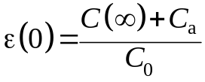; 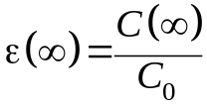.
Dielectric contribution of migratory polarization equals to ε(0) – ε(∞).
Further consideration should be given for general scheme (Fig. 2.18, a), without neglecting conductivity. Taking into account rC_{а} = τ_{a}, it can be found

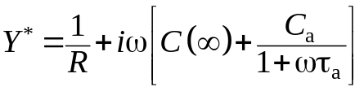.

After separation of real and imaginary parts of this expression and using simple transformation it can be obtained
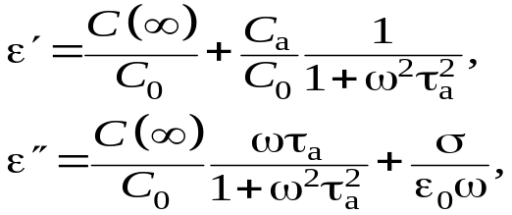 , (2.44)

where σ is the conductivity that is taken into account in the equivalent circuit by parameter R. Thus, the model of an inhomogeneous dielectric shown in Fig. 2.18 can be considered sufficiently universal. When compared with the experiment, it might be possible that the relaxation spectrum of dispersion, as a rule, is more blurred than it follows from equations (2.43) and (2.44). This circumstance may be overcome by the inclusion in the equivalent circuit the several units r_{і}C_{аі} describing accumulation of space charge by inhomogeneous in the dielectric with several relaxation times (Fig. 2.18, b). Thanks to this method, the blurred depending of ε(ω) over a wide frequency range can be explained.

Summary to Chapter 2

1. The most important macroscopic characteristic of dielectric is the permittivity ε. In the non-centre symmetric crystals and textures it one should be aware that ε_{ij} is a second-rank tensor; therefore, due to dielectric’s anisotropy permittivity can vary greatly in different directions. This parameter depends also on many conditions. For non-centre symmetric dielectrics the permittivity must be distinguished between mechanically clamped and mechanically free dielectric. In the polar dielectrics there is a difference between isothermal and adiabatic permittivity.

2. In the macroscopic theory, to describe the polarization of dielectrics the vector polarization P is introduced which is numerically equal to the electrical moment per unit volume of the dielectric, and directed in accordance with the characteristics of symmetry of the dielectric as well as the direction of the electrical field in the dielectric E. In an isotropic dielectric vectors P and E are collinear.

3. The macroscopic field in the dielectric is in ε times less than in a vacuum as it is created only by the "free" charges on the electrodes (these charges are not compensated by arisen polarization which causes only a part of the total electric charge). Therefore, the electrical induction vector D is introduced in order to characterize the total charge on the electrodes.

4. Vectors P, D and E are bound by a simple relation D = ε₀E + P that can be obtained in the macroscopic electrodynamics by the averaging of Maxwell's equations for the physically infinitesimal volume and time interval. The result can be obtained by Maxwell's equations in matter D = εε₀E. For most dielectrics, these equations are simplified by the assumption that relative permeability μ = 1. The energy of dielectric polarization in the electrical field can be found from Maxwell's equations as well.

5. The induced by electrical field polarized state of dielectric can be described by several mechanisms of elastic, thermal and space-charge polarization at which the displacement of electrons, ions or dipoles occurs in the external electrical field.

6. The quasi-elastic (deformation type) polarization is almost independent of temperature, and it is the least inertial polarization, so it determines the high-frequency and optical properties of dielectrics.

7. Electronic elastic polarization is a common mechanism of polarization, since the deformation of the electron shells of atoms or ions in an electrical field occurs in all the materials. In addition, it is practically no-inertial polarization mechanism, since the mass of the electrons is much smaller than the mass of other particles (ions or molecular dipoles) involved in the process of polarization. The rapid settling of the electronic polarization allows select its dielectric contribution by optical experiments.

8. Ionic elastic polarization is peculiar to such dielectrics and semiconductors, in which the ionic character in molecules or crystal lattices is expressed. Time settling of this mechanism is significantly greater than in the case of electronic polarization as the mass of ions is large compared with the mass of electrons. However, the time needs to establish the ionic polarization (~10^{–13} s) is still much smaller than the relaxation times for thermal and space-charge polarization of dielectrics.

9. The model of elastic dipole polarization might be applied only in the case when external electrical field forcedly changes direction of spontaneously oriented dipoles (however elastic force arises tending to return to the previous orientation of the dipoles). For this mechanism the existence of internal polarization is necessary, at which the dipoles would be oriented and connected in the structure. Obviously, the elastic dipole polarization can occur mostly in the solid dielectrics – polar crystals, but this polarization can also occur in the liquid crystals as well. The inertia of this polarization is low and comparable with ionic polarization.

10. Mechanisms of thermally activated (relaxation) polarization are conditioned mainly by the structural defects in dielectrics, and lead to the ε-dispersion and dielectric losses at low frequencies and radio frequencies. The thermal motion of the particles in the dielectric may greatly affect on polarization process, if dipoles, ions or electrons are weakly bounded in dielectric structure. Remaining localized in the nano-regions, these particles, under the influence of the thermal motion, can make thermal jumps, moving at atomic dimensions distance.

11. Thermally activated dipole polarization (Debye mechanism) is peculiar to polar gases, liquids and crystals. When external electric field is absent (E = 0), the dipoles are oriented randomly, so the electrical moment per unit volume (polarization) is zero. If E > 0, then thermal chaotic motion of the dipoles becomes partially oriented along the field, with the result that there is a new state of equilibrium – polarized. In this case, thermodynamic equilibrium is due to thermal motion (vibrations, rotations) of dipoles becomes favourable for field orientation, however the same thermal motions prevent full orientation of the dipoles in the electrical field, so only some of the dipoles are oriented. The higher the electric field strength, the greater part of the dipoles becomes oriented, that causes the thermal dipole polarization. The average electrical moment per molecule is proportional to electrical field acting on the dipole. The settling time of this polarization is relatively long (τ = 10^{–3}...10^{–9} s), and it is strongly dependent on temperature.

12. Ionic polarization is due to thermal jumps of weakly coupled ions (usually – impurity ions) in a local area of lattice, and thus such a polarization arise mainly in solid dielectrics with defects in their structure. Ions in the interstices, as well as ion vacancies (voids in a regular structure) may change the place of their location under the influence of thermal fluctuations. During these movements, that is limited by the structural defects (dislocations, for example), the ions overcome potential barriers and jump in the new positions, creating electrical dipoles. In the absence of an external electric field, the locally limited movement of charged particles is disordered, random and cannot lead to a macroscopic polarization. However, in the external electrical field, the distribution of ions in the defect sites of crystal lattice changes, resulting in an electrically induced thermal ionic polarization.

13. Thermal electronic polarization is peculiar only to solid dielectrics. Captured by vacancies electrons (holes) can lead to thermal polarization only in the case when the ground state of electrons is degenerate, and the combination of degenerate wave functions can create dipole moments. In the absence of an electrical field, under the influence of thermal fluctuations, the electron or hole moves from one to another place of localization. However, this chaotic movement of charges does not lead to the polarization if the external electrical field is absent. This field switching on stimulates the "unipolarity" of electronic transitions, and leads to field induced electrical moment per unit volume of the dielectric, i.e., increases the polarization. Relaxation time of thermally activated polarization is quite big: 10^{–2}...10^{–6} s.

14. Not all possible types of polarization are equally frequent in real dielectrics and play the same role. Moreover, it is impossible to consider various mechanisms of polarization completely independently of each other – on the contrary, considered basic mechanisms can influence each other, and only to facilitate their study they are discussed as independent. However, in many cases, this analysis is a sufficiently accurate approximation.

18. The electrical field acting on the dielectric particles (local field) is different from the macroscopic field conditioned by polarization – due to the particle nearby environment. In the Lorentz approximation, a formula is obtained for dielectric constant calculating from microscopic parameters of dielectric:
(ε + 2)/(ε – 1) = (3ε₀)^{–1}∑n_{k}α_{k},
where α_{k} is the polarizability and n_{k} is particles concentration that make varying polarization.

19. Migratory polarization is an additional mechanism of polarization, which may exists in the solid dielectrics with inhomogeneous structure of macroscopic violations and impurities. This slow polarization has no time to be set at high frequencies, but causes a significant dissipation of electrical energy (losses). Possible reason of this polarization appearance is the presence in the dielectric some layers of different conductivity or semiconducting inclusions in technical dielectrics.

